REVIEW OF DLDP ACTIVITIES IMPACT IN PLANING
(Final-draft REPORT)

Authors: Prof. Dr. Besnik Aliaj
MSc Ledio Allkja

December 2016
Abbreviations
dldp Decentralization and Local Development Program
FA Functional Areas
FAP Functional Area Plan
GLP General Local Plan
GNTP General National Territorial Plan
KM Knowledge Management
LGU Local Government Unit
MTBP Medium Term Budgeting Program
NTC National Territorial Council
SDP Strategic Development Plan
TAR Territorial Administrative Reform
Contents
Chapter 1- Introduction 5
1.2 Theoretical Considerations 5
1.3 Structure of the report 9
1.4 Methodology 9
a. Desk study based on literature review 9
b. Interviews with relevant stakeholders 10
c. Focus Group 11
Chapter 2- Strategic Planning Activity of DLDP 12
2.1 Territorial Planning Framework in Albania 12
2.2 Territorial Administrative Reform 13
2.3 SDPeMTBP 14
2.3.2 Content of SPDeMTBP 16
2.3.3 Results 18
2.4 Functional Area Study 18
2.4.2 The process 20
2.4.3 The results of the Functional Area study 21
2.5 Functional Area Program 23
2.5.2 Results of the FAP 28
2.5.3 Territorial Development Strategies 29
Chapter 3- Impact of Strategic Planning 31
3.1 Impact at National Level 31
3.2 Impact at the local level 32
Chapter 4- Knowledge Management DLDP 33
Chapter 5-Conclusions and Recommendations 34
5.2 Future short-term and mid-long term 36
5.2.1 Short-term (2017-2018) 36
5.2.2 Mid-Long term (2018-…) 37
Appendix 1- CENTRAL PLACE APPROACH (GERMANY) 41
Appendix 2 (Case study in Strategic Planning) 44

Fig. 1- Strategic Planning (dldp 2012) 17
Fig. 2- Hierarchy of Centers 20
Fig. 3- Spatial Planning in Germany (Newman & Thornley, 1996) 21
Fig. 4- Berlin Hierarchy of Centers 22
Fig. 5- concentric model (Bushati, B., et al 2014) 25
Fig. 6 Polycentric Model (Bushati, B., et al 2014) 26
Fig. 7- cross border model (Bushati, B., et al 2014) 26
Fig. 8- General Description (FAP Malesi e Madhe, dldp 2015) 28
Fig. 9- Example of Economic Interrelation Analysis, Lezhe Municipality (dldp 2015) 30
Fig. 10- Mapping local services (FAP Kukes, dldp 2015) 31
Fig. 11 Themes for future actions 38

Map 1- Administrative Map Albania 14

Table 1- Interview Coding 10
Table 2- FA study indicators (Bushati, B., et al 2014) 23
Table 3- FA study work methodology (Bushati, B., et al 2014) 23

Chapter 1- Introduction
The decentralization and Local Development Programme (dldp) is operating in Albania since 2006, creating a good cooperation with municipalities in building capacities for local development and fostering decentralization. The program has established substantial experience in the preparation of instruments for strategic planning, namely the Strategic Development Plans. The dldp approach on strategic planning linked with medium term budgeting in seen as one of the trademarks of the program on this topic.
At the start of its third phase, (dldp 3), a research was conducted in order to identify LGU clusters that could have the dynamic potential to influence the larger territory of the region. During this phase, the territorial coverage area of the program was also expanded, involving five “Qarks” (districts/region) of Northern Albania comprised of Shkoder, Lezhe (existing cooperation during dldp 1 and 2) and Durres, Diber and Kukes. The “Functional Areas” research was conducted in five regions giving some important insights both to the program and to the identification of potential partners. This research was conducted during a “critical juncture” in terms of the territorial reform, and its insight became also part of the methodology for the territorial reform by the central government.
As a natural next step of the identification of the Functional Areas, dldp focused on preparing Functional Area Programs (FAPs). The FAPs are analysis and programming documents focusing mostly on economic development, public services and governance projects on the geographical territories of the Functional Areas. In certain cases, the FAs correspond with the administrative territories of the newly created municipalities, while in other cases FAs cover more than one municipality. The FAPs were meant as a transition tool, to understand the dynamics and territories of the possible new LGUs specifying some quick interventions that would improve the internal cohesion and trigger the economic development of the territories.
FAPs as documents were created in a unique moment, studying the territory of the new LGUs and there is agreement that they contain a part of the analysis required by the planning legislation for a Territorial Strategy. Hence it was agreed to expand these documents into Territorial Strategies for the newly established municipalities.
Afterwards, dldp agreed to support the LGUS with the preparation of the General Local Plans (GLP-s integrated with the Medium Term Budgeting). Hence, in order to respond to an evolving context (territorial reform, urban planning legislation, new law on local self-government and draft law on local finances), dldp tools for strategic planning have evolved rapidly.
In addition, to the support for the preparation of strategic planning documents, dldp has a well-founded approach for the dissemination of knowledge, training and coaching of local partners. The Centers of Competence can be seen as one of the highlights of dldp Knowledge Management, which combined with new curricula’s, training, seminars, study visits form the pillars for supporting capacity building at the local level.
The objective of the assignment is to review the current dldp activity (last phase assessed in coherence with the previous ones) related to planning (SDPeMTBP), understand the impact of these activities and recommend the next steps of the program in this context in the short (2017) and medium time-frame (2019) as well as a long term prospect.

1.2 Theoretical Considerations
Based on previous reports and programming documents of dldp, its impact hypothesis is as follows:
‘Through strengthening the capacities, internal processes and systems of municipalities and communes in five Qarks in Northern Albania, their socially inclusive service delivery to citizens (men and women) is improved. Good practices and tools are consolidated and disseminated in and outside the project area by horizontal (sectorial) and vertical integration (government levels) that should lead to sustainable use of the produced knowhow. The generated evidences will be used and thus contribute to a more conducive legal framework and decentralization reform and ultimately deepen local democracy.’ (dldp 2015)
Given the peculiar moment in which phase 3 has evolved, as well as, the rapid evolution of its strategic planning approach, a more theoretical overview is necessary to be conducted through literature review in order to better define the objective, as well as, the meaning of the term “impact” for this report.
First, it is worth to define strategic planning and its objectives, an approach initially applied from private corporations and then transferred also to public organizations. Strategic planning is defined and quoted by different authors, to mention Bryson (2004) outlining it as “a disciplined effort to produce fundamental decisions and actions that shape and guide what an organization is, what it does, and why it does it” [p.6]. Meanwhile, Mintzberg (1994) sees the concept of formalization as key to understand planning. His definition of strategic planning is a "formalized procedure to produce articulated result, in the form of an integrated system of decision" [p.12]. Wilkinson and Monkhouse (1994) define strategic planning as “a method used to position an organization, through prioritizing its use of resources according to identified goals, in an effort to guide its direction and development over a period of time” [p.16].
Based on the above definitions, it can be concluded that strategic planning in public organizations analyzes external factors influencing their operations, perceives internal strengths and weaknesses and, and on that basis, sets organizational goals and takes all necessary measures in order to achieve planned goals. In addition, Bryson lists five benefits of strategic planning in the public organizations such as: 1) promotion of strategic thinking and action, 2) improvement of a decision making process 3) improvement of organization, 4) improvement of the overall organization of work and results within an organization and 5) strategic planning can directly benefit all employees within the organization [Bryson 2004, p.5].
Another important benefit of strategic planning as well as reason for this approach being braised by public organizations is related to the flexibility that it offers. Given the dynamic developments due to greater internationalization and globalization pressures strategic planning offers a flexible and more responsible tool in dealing with continuously changing and dynamic processes when compared to statutory, rigid and bureaucratic approaches (Cities Alliance 2005). Not being regulated by law, strategic planning can be used by different levels of governance in order to tackle different development needs ranging from local economic development, poverty alleviation, organizational processes and so on.
Meanwhile Spatial Planning has been in the attention of many academics, researchers and government officials for several decades as it is a tool, which allows for the planning and management of the territory (Pike A. et al 2006). As such it is an integral part of any governance puzzle for the management of territories, economic potential, social capital and environmental resources.
However, the concept of ‘spatial planning’ is used in different ways depending on the context (especially legal and governance system) and purpose, hence it is worthy to make the distinction of the two main ways in which it is conceptualized:
- “the name of the governance system for managing spatial development and/or physical land use in a particular place (the national or regional planning system)
- as a specific term to describe ‘the spatial planning approach’, a particular idea or definition of spatial planning that has arisen through debate at the European level” (Duhr et al 2010, p26)
However, let`s not mix spatial planning with the rigid urbanism or land use planning approach. The strategic turn in spatial planning can be also considered as a result of the above discussion on strategic planning becoming part of a governance procedures in search of more flexibility and less rigidity in trying to respond to fast evolving territorial/spatial challenges. In this sense, strategic planning (non-spatial/territorial) and strategic spatial planning can also be considered as two parallel processes, with the latter being more concerned for a strategic approach in territorial issues while the first spanning in a broader range of themes and topics depending on the challenges and specific issues that a certain governmental institution may be faced with. Therefore, it is important to be acknowledge this fact that the two processes are not always necessarily linked with each other.
According to Albrechts (2004) strategic planning is “a public-sector-led socio-spatial process through which a vision, actions and means of implementation are produced that shape and frame what a place is and may become”. As it can be seen from this definition, the strategic approach has some of the main qualities that were required at the time to move away from the inflexible land-use planning. Strategic (spatial) planning was born to be inherently inclusive. It also uses a strong evidence base and takes into account the different strengths, weaknesses, opportunities and challenges, it allows for inclusion of different trends and external forces that may influence the area. In addition, it makes use of images, visions and maps, which allow for a better understanding of the area, as well it develops long-term strategies and perspectives at different levels (Albrechts 2004). Also, it has a focus on decisions and implementation and allows for monitoring, feedback and revisions.
As a result, strategic spatial planning is an open process, comprehensive by nature, very close to the problems, it is continuous, it makes use of different tools and approaches which allow for long term-strategies and visions, and has the great ability to ling strategic thinking with territorial dimensions and land development decisions. Due to the fact that strategic planning ‘per se’ is a concept with relatively high flexibility and broadly defined, in different contexts or governmental instances it may take different approaches depending on the interpretation or the needs.
A complex mixture of factors such as historical and cultural conditions, geography, constitutional and administrative arrangements, levels of urban and economic development as well as political and ideological aspirations had led to a large variety of systems with different objectives, instruments and techniques for planning spaces (Duhr et al 2010). Therefore, different spatial planning cultures have emerged, which Faludi (1999) defines as the collective ethos and dominant attitudes of planners regarding the appropriate role of the state, market forces and civil society in influencing outcomes; whereas Friedmann (2005, p184) defines as ‘the ways, both formal and informal, that spatial planning in a given multi-national region, country or city is conceived, institutionalized and enacted’. As it can be seen from these definitions, ‘culture’ (and all its related structures, processes and systems) is an integral part of planning systems as it reflects accumulated attitudes, values, rules, standards and beliefs that are shared by planners and other actors.
The concept of planning culture in this sense it is important for understanding the way that strategic spatial planning evolves in different territories as well as in the way different policy issues and policy transfers occur. Therefore, local context plays an important role not only in the way that strategic spatial planning is conceived but also in the use, application and implementation of different “borrowed” approaches or “best practices”.
dldp approaches in strategic planning (phase 3), have developed and evolved in a situation of many uncertainties, albeit/because of territorial (the new municipalities were still in conception) and legal reforms (territorial planning and development law was under revision, law for self-governance of local authorities was being drafted, law on local finances is still being drafted). Also, most of the documents and strategic planning documents/approaches under the umbrella of phase 3, have only been developed in a time period of 2 years, with some of them still not having entered the implementation phase. Therefore, it is difficult and inappropriate for the time being to assess their territorial impact. Thus for the purpose of this report (based on the above literature review, the impact hypothesis of dldp, the log-frames of the programming documents of dldp and the Albanian context), by impact is meant: the support that these tools/documents have given to newly created local authorities in terms of organizing and operationalizing work in their early stages; the amount of projects from FAP/SDP/TDS that have been implemented, developed and are being developed; and the contribution of these documents towards future territorial planning documents for the municipality. Meanwhile at the national level, impact will be defined in terms of the cooperation that dldp has raised with national institutions of planning, as well as the way this cooperation has been translated in support for the local level.
Another important aspect of the report is also to analyze the approach that dldp takes with regard to knowledge management and the way it disseminates its activity. In this case, the definition of diffusion as “the process by which an innovation is communicated through certain channels over time among members of a social system” (Berry and Berry, 1999: 171) is taken in consideration. Diffusion comprises a trend of successive or sequential adoption of a practice, policy or programme. Thus, policy transfer and learning are two of the key outcomes of diffusion. Policy transfer can be defined as a process through which ‘knowledge about how policies, administrative arrangements, institutions and ideas in one political setting (past or present) is used in the development of policies, administrative arrangements, institutions and ideas in another political setting’ (Dolowitz & Marsh, 2000: 5). In addition, policy transfer can involve a number of processes and the objects of transfer comprise (i) policies, (ii) institutions, (iii) ideologies or justifications, (iv) attitudes and ideas, and (v) negative lessons (Dolowitz, 1997). According to Dolowitz & Marsh (1996: 351) there are different degrees of transfer: straight-forward copying of policy, legislation or techniques as well as various forms of emulation, synthesis and hybridization, and inspiration.
In addition, transfers can be either voluntary or coercive or combinations thereof (Dolowitz and Marsh, 2000: 13-17). Terms such as ‘lesson-drawing’ (Rose, 1993) and ‘systematically pinching ideas’ (Schneider & Ingram, 1988) portray transfer as a voluntary and somewhat rational activity. Other terms emphasize compulsory conformity; that is: ‘penetration’ (Bennett, 1991) and ‘external inducement’ (Ikenberry, 1990).
However, it is worth mentioning that transfers of ideas or programs are sometimes dependent by deeper and prior process of learning. Thus, the emphasis is on cognition and the redefinition of interests on the basis of new knowledge which affects the fundamental beliefs and ideas behind policy approaches (Hall, 1993). Therefore, the importance of learning in the dissemination and policy transfer process is essential. Policy learning may result in a more coherent transfer of ideas, policies and practices whereas mere copying may well be ad hoc and piece-meal. Policy co-ordination and/or implementation is more likely to result when there is a reasonably wide consensus of the desirability of introducing policy lessons among actors inside and outside government. This literature review, serves as a basis for assessing the different modes of policy transfer and policy learning that are used by dldp in its work with LGU as well as to achieve the aims of the program.

1.3 Structure of the report
The first chapter of the report is composed by the introduction, which main aim is to set the scene for the assessment. After a short description of dldp work during phase three, a short literature review is conducted with the aim of defining “impact” of strategic planning as well as to expand the discourse in terms of the meaning of “strategic planning” and “strategic spatial planning”. This will serve as the basis for the analysis of the report. In addition, this chapter describes the methodology used for developing the analysis and the assessment.
The second chapter contains a description of the methodologies, including the reasons that led dldp into employing these tools overtime. It also contains a justification of the evolution of these tools. The comparison between these tools in this chapter is intended to cover only methodological aspects and not the respective impacts. However, the chapter will discuss whether the evolution of the dldp support has been responsive both to the needs of a changing environment as well as to the results in the log-frame. Therefore, it is important firstly to also describe the evolution of the decentralization process and the evolution of territorial planning in Albania before going deeper into dldp instruments. The chapter devices a comparison with the current territory planning framework principles and instruments in Albania, as well as short illustrations of how other countries deal with similar cases/issues. These case studies of reduced text are put into boxes. It is crucial to mention here that territory/spatial planning is a decentralized practice and it is extremely diverse and context based. Each best case is best in its own context and should be carefully assessed and modified if decided to be imported out of its context
The third chapter is the evaluation of the impact of FAP and TDS vis-à-vis SDP&MTBP. It is difficult to make a full assessment of the impact of these tools as their implementation life has been rather short and the whole dldp methodology has been in continuous adaptation, in a context of subsequent/parallel reforms – territorial and administrative, governance and decentralization, territorial planning, etc. However, it shows how the different instruments have made their way into the institutional functioning of the local governments and what has been their use in the short-term period of the assessment. This helps in drawing some conclusions that dldp can use to further advance its knowledge management policy.
Chapter 4 focuses on the contribution to the advancement of the dldp policy framework and knowledge management strategy. This part shortly describes the evolution of the dldp KM strategy and the positioning of the dldp planning tools overtime within the KM. It contains recommendations for the KM strategy of dldp from a broad angle. It is built based on the conclusions of the chapter 3.
The last chapter focuses on conclusions and recommendations for future steps. These future steps regard only the planning tools/instruments and the related role of dldp. They include short-term improvements on what is currently going on or planned, as well as long-term suggestions on possible dldp positioning n the local territory planning context.

1.4 Methodology
The methodology of the assessment is based on three main pillars such as:

Desk study based on literature review
The literature review included a revision of the dlpd programming documents/Logframe methodologies of Strategic Development Plan, Functional Area Programmes and Territorial Strategies. In addition, a sample of the prepared SDP-s, FAPs and territorial strategies will be reviewed and compared vis a vis international good practices as well as the current legal and methodological framework for territorial planning in Albania. Lastly, a review of the policy framework and KM strategy of dldp has been conducted.

Interviews with relevant stakeholders
Primary data were collected via semi-structured interviews, which can typically be referred to as ‘a context in which the interviewer has a series of questions that are in the general for of an interview schedule, but it is able to vary the sequence of questions.’ (Bryman 2008 p.437)
In order to assess the various impact, a sample of interviewees was carefully selected in order to be as comprehensive and inclusive as possible. Interviews were conducted with dldp staff and experts (3 interviews), interest groups, partners and collaborating institutions of dldp at central level (Ministry of Urban Development, National Territorial Planning Agency). In addition, interviews were also conducted with service providers involved in the process. Lastly local government officials were interviewed to better understand the impacts.
The interviews have been conducted in the ‘traditional’ way, in person or via a skype call, where the interviewer sits/stands in front of the respondent asking questions and recording the answers (Bryman, 2008). For the purpose of this study open questions have been used, meaning that respondents have the freedom to answer the questions the way they wish, without being restricted by the interviewer. This is important when considering the socio-constructionist philosophy of the research where the concern is on understanding the meaning of different phenomena to the respondents (Sanders, 2007). Two of the main advantages of open questions, are that they allow for unusual responses to be derived, as well as exploring new areas or ones in which the researcher has limited knowledge (Bryman, 2008). The researcher had formulated a ‘pool’ of questions relevant to the study and for each interview 5-6 main questions, appropriately chosen for the respondents, by taking in consideration their position, in order to gain the best out of their expertise. In addition, depending on the answer the interviewer, questions were formulated to seek explanation of the respondents answer in the process of the interview. The interviews lasted between 20-30 minutes and they were conducted in Albanian and in English.
Interviews have been coded in order to be used in the text. They have been divided according to the specific target groups and assigned number.
Table 1- Interview Coding
Code | Interviewee
dldp
dldp 1 | Valbona Karakaci | dldp representative 1
dldp 2 | Erton Kashta | Dldp representative 2
dldp 3 | Elvin Hoxha | Dldp representative 3
EXPERT INVOLVED IN DLDP PROGRAMING
EXP 1 | Blendi Bushati | Expert 1
EXP 2 | Stefan Pfaeffli | Expert 2
EXP 3 | Fred Wenger | Expert 3
SERVICE PROVIDER
SP 1 | Manjola Duli | Service provider 1
SP 2 | Besnik Alku | Service provider 2
SP 3 | Sabina Ymeri | Service provider 3
NATIONAL GOVERNMENT PLANNING
NGP 1 | Nertil Jole | National government representative
LOCAL GOVERNMENT UNIT
LGU 1 | Mat Municipality | Mat Municipality representative

The codes above will be used for referring to the interviews in text, hence when directly quoting the interviewee will be referenced to the same as literature, so for example “quote” “DLDP 1”. In order to preserve the confidentiality of the interviewees their names are kept anonymous.

Focus Group
A workshop was conducted with a focus group composed by dldp experts and other actors to discuss the findings of the preliminary report. The focus group workshop came at a very important stage for validating some of the first results of the assessment. Firstly, a powerpoint presentation was given to the panel in order to showcase some of the main findings of the preliminary report. The emphasis was also on highlighting some of the impacts and possible future actions that the dldp could take. After the presentation a round of questions and answers were done in order to clarify some issues which may not have been clear or fully explained during the presentation. In the end the roundtable was focused on brainstorming with regard to the future actions that dldp could take. The presentation offered a scheme for structuring the discussion.

Chapter 2- Strategic Planning Activity of DLDP

2.1 Territorial Planning Framework in Albania
Urban development in Albania has undergone three main phases, where the first two phases are treated below and belong to 1990-2009 and the third phase started after year 2009 (MUD 2014).
The first phase encompasses two major phenomena:
- the creation and development of the informal settlement sector, which started in year 1991. The transformation of the political system and application of shock therapy in the first years of democracy, coupled with state’s withdrawal and greater liberty of the free market, had a great impact on the territory. The migration of population from suburban areas to major urban centers in the western plains of the country was one of the most significant phenomena in post-1990 Albania. This fact is certified by the shift in the population percentage living in urban areas. For the first time in its history, Albania has a majority of urban population (54%), as stated by INSTAT’s Census of 2011. In addition, 36.1% of the country’s population lives in Tirana and Durres regions – 26.7% in Tirana and 9.4% in Durres. Coupled with ambiguities stemming from the reform on privatization of land and with the government’s inability to control urbanization, the population influx to western areas brought about the informal settlement/ building sector in many of these urban centers.
- the first attempts to have a decentralized governance (mainly political and administrative at this phase) are visualized in the planning system too. The first law on urban planning was approved in 1993. It did not contain any provision that could address strategic planning or informal developments.
The second phase of the urban development coincides with the first attempt to consolidate the legal system for the construction and urban planning sector, with the entry into force of the Law No. 8405, ‘On Urban Planning’, i.e., in the year 1998 and afterwards. A rapid establishment of the formal construction sector, next to the consolidation of the informal one, is seen. This urban planning law maintained still the same rigid approach towards planning, considering it mainly as “the tool to define the location of the object on the urban territory” (8405/1998). The regulatory plan (introduced by the law) was a rigid instrument and sought to indicate the siting and the use of buildings in the town. It did not cover rural areas, but the residential neighborhoods in villages. This fact continued to encourage informality in one way or another. One of the major concerns with the legislation and practice of planning related to the negligence of the context. Therefore, while attempts have been made to develop various regulatory plans, lack of special implementation instruments has caused the failure of the implementation phase of these plans. Further, the regulatory plan was not mandatory to development. Thus, a developer could receive a building permit by simply drafting a “partial urban study” for a specific area, and have it approved by the authorities. It has been acknowledged that this phase reached its peak in 2004-2007, in which the number of informal settlements increased substantially and the governments took measures by means of policies and legal instruments to formalize this economy, even though this effort has not accomplished its mission. In this very period, there was a boom of formal economy in the building sector.
The third phase of urban/territorial development in Albania commenced in 2008-2009, during which the central government undertook reformation steps towards the territorial planning legislation. The aim in this phase was not only to change the planning law but also the planning approach from a more urban based one towards a more spatial territorial approach. In 2009, the law no. 10119 “On Territory Planning” was approved and set to enter into force in 2011. The 2-year transitory period was meant to serve as period of adaptation and adjustment, for increasing capacities and prepare the different levels of government to adapt to the new system. The major change the new legislation brought about, stands in the new principles and planning mentality it introduced. Thus it made a substantial jump for planning, from urban and land-use centered, to spatial and sustainable development focused. However, for several reasons (which are not the key purpose of this paper) the new system never managed to become fully functional. For a while it was a political priority of the central government, but then the following amendments, especially those to the bylaws, were mainly driven by the needs of the big municipalities, such as Tirana, without reflecting smaller local government’s needs. This led to a malfunctioning of the planning system and to a stale mate. The planning process from a positive and promoter of development turned into an obstacle for development – at least this is how it was perceived, hence many people continued to opt for informality.
The changes of government in 2013 put spatial planning back into the political agenda. The law was reviewed and its bylaws were redrafted. The new law no. 107/2014 “On territory planning and development” maintained the principles of the law no 10119/2009, but simplified the legislative language and procedures, to facilitate understanding and acceptance by the users. What is most important, the law drafting process was open and participatory, which was key to the acceptance of the law at an early stage. Sustainable development remains one of the key principles of the law, together with the need for transparency, strategizing and comprehensive analysis and thinking. Furthermore, the law promotes decentralization and subsidiarity principles, defines the mandatory spatial planning hierarchy and defined strategizing as a key preliminary steps in the territory planning process. Thus spatial planning is both strategic and statutory/regulatory. Finally, the law defines that the GLP should be drafted for the whole administrative area of the municipality. Currently there are three main bylaws for the implementation of the law: DCM no. 408/2015, the development regulation; DCM no. 671/2015, the planning regulation; and DCM no. 1096/2015, the public space regulation.
DCM no. 671 defines the composing documents of the General Local Territory Plan, and gives indications on their structure. The documents are the following:
- The integrated GIS database;
- The Territorial Development Strategy
- The Territorial Development Plan, including the Capital Investment Plan
- The GLP Regulation
- The Strategic Environmental Assessment
The Territorial Development Strategy should contain a comprehensive all-encompassing territorial analysis (social/economic and environmental, together with the metabolism analysis); a strategic vision and subsequent strategic objectives, programs and projects; the related action plan and financial analysis; visualizing maps. The territorial development plan will contain a more in-depth multi-dimensional territorial analysis; the land-use plan; the infrastructures plan; the environmental plan; the capital investment plan; the GLP implementation plan and monitoring indicators; Maps.

2.2 Territorial Administrative Reform
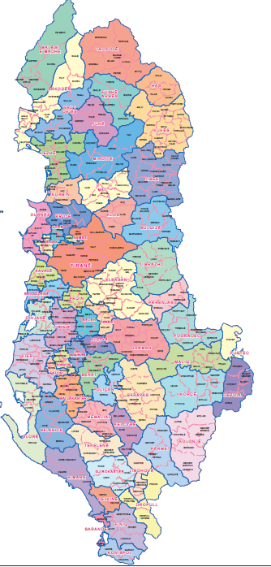
Decentralization in Albania has gone through different phases since the fall of the communism. In 1992, the Council of Ministers introduced changes to the administrative-territorial organization of the country, based on the article 1 of the law nr.7572, dated June 10, 1992 “On the organization and the functions of the local government.” This law prescribed for 36 districts, 44 municipalities, and 313 communes. Local councils were established at the municipality and commune level with members elected by the citizens. The mayors and the heads of the communes were also to be directly elected by the people. Later, the law nr.7608, dated September 22, 1992 “On the prefectures” mandated the establishment of 12 prefectures as units headed by the prefect who is appointed by the Council of Ministers.
During 1992 – 2000 several partial changes to the administrative-territorial organization of the country took place but without any major structural changes. In 2000 Albania had 36 districts, 65 municipalities, and 309 communes. In 2000 the law nr.8653, dated July 31, 2000, abolished the districts (rrethet) as administrative units and re-established the regions (qarqet). Starting in 1992, the municipalities are established only in towns. In few exceptions they might include a town and few villages. The communes, as a rule, include only villages. In few exceptions a commune might include a town. Albania has currently 12 regions (qarqe), 308 communes, and 65 municipalities
In 2013 the government set as one of the main priorities of its program the undertaking of an administrative and territorial reform, with a view to increasing efficiency of local public services and strengthening the power of local government units.
On May 16, 2014, the Minister of State for Local Issues, relying on the adopted criteria, presented a proposal based on five variants of the new administrative and territorial division map. In the end, the option for 61 Municipalities was accepted and approved by the parliament.

2.3 SDPeMTBP
The general legal context for preparing the SDP was derived from the Organic Law of 31/07/2000 “On the Organization and Functioning of Local Governments in the Republic of Albania.” In general terms, the law established that starting in 2001 the communes and municipalities would be responsible for carrying out their own functions. More specifically, they were responsible for (1) the preparation of local economic development programs, and (2) the organization and provision of services, information and respective infrastructures to support local economic development.
Map 1- Administrative Map Albania
Therefore, during the period 1998- early 2000s different strategic plans started to be drafted in Albania at central and both tiers of local governance such as the “districts” and municipalities and communes. These strategic plans were developed and supported by different international donors in Albania such as for example UNDP for the “districts”, USAID and the World Bank which worked with municipalities and later on during the period 2004-2006 by Co-Plan through CDS. These first attempts developed by different actors also took to a certain extent different approaches towards strategic development and served as a first basis for initiating strategic thinking and planning in Albania.
Meanwhile in 2008, law No.9936 of 26/06/2008 “On Management of Budgetary System in the Republic of Albania” formalized the Medium Term Budgeting (MTB) Program as a legal instrument not only for the central government but also for local governments. According to this law, the MTB Program is defined as a 3-year expenditure plan that links programs to activities, outputs, objectives, and policy goals. Adding to the legal framework, MoF’s Guideline No.7/1 of 22/02/2010 “On the Preparation of Local Budgets” determines all the steps to be followed in preparing the MTB Program. According to MoF’s guidelines, the preparation of the MTB Program is related to the SDP, sector and cross-cutting sector strategies within the framework of the Integrated Planning System (IPS) for all the issues related to the local level.
In this context, under dldp program phase 2, an initiative was taken to develop a methodology for drafting Strategic Planning linked with the MTB which would serve as support to authorities in their processes. The methodology for developing Strategic development plan was prepared by Co-PLAN, Institute for Habitat Development. Within this framework, the SDP was introduced as an instrument that serves the local government as an overall umbrella.
The Strategic Development Plan (SDP) is a strategic document whose implementation timeline can span between a minimum of 4-5 years to maximum of 10-15 years. The SDP was not simply seen as a local activity or document, it served a bigger function. It serves both as a point of reference and a source of synergy for the coordination of activities that affect not only the public sector but also the collaboration with the private sector, civil society, and in particular the local communities and citizens of each LGU. The creation of a SDP provides an instrument for development. It ensures efficient and effective provision of services in line with local financial resources. It also mobilizes other funding resources by introducing a well-organized plan of action the progress which is measurable. The SDP is the “guiding document” for development at the local level for both the local government and the citizens in its territorial boundaries.
This manual was prepared for the purpose of assisting local governmental units in their processes of SDP planning, monitoring, evaluating and reporting. The purpose of this document was to provide information on the general methods and processes that need to be undertaken and provide instruction on how to carry out these processes. The manual draws from many resources, handbooks, and training materials in an attempt to put the most relevant information in one convenient location. It also builds on previous experiences in strategic planning in Albania in order to develop a methodology which is context base and can applied in the Albanian context.
Specific attention was given to the processes of planning, reporting, controlling and evaluating. The manual focuses on:
- Using broadly-accepted terms, with the intent of establishing a common understanding of what planning is and why and how it is done;
- Defining the relationship between MTB Program and Strategic Development Plan for Albanian local authorities and;
- Integrating MTB Program with the strategic planning process
The Manual was meant to provide guidance to local government authorities on how to prepare strategic development plans (SDPs) incorporating the MTB Program, as well as how to enforce reporting and controlling on them. It also provides a set of instructions and processes on how to better implement directives found in the respective laws regarding the planning and budgeting processes in Albania.

2.3.2 Content of SPDeMTBP
According to the manual the SDP document takes the shape of a typical strategic document composed of an analysis, vision setting, objectives, programming and then afterwards their link with the mid-term budget plan. A short description of the methodology and the approach that this manual takes are given below. The analysis, covers different factors although, not from a spatial perspective:
- population and future housing trends
- community development, transportation
- rural areas, infrastructure
- built and natural heritage
- enterprise and employment,
- recreation
- leisure and tourism
- public services
- infrastructure conditions
- social and health conditions
- educational situation
- institutions operating
- economy and business
- local finances availability
A vision-and strengths-based approach moves away from problem-based planning, which focuses on constraints. Instead, this approach looks at where a community desires to be and how to get there. It is important however for the community to look back and see where they have been and where they are today before looking into the future to see how and where they want to be in a given period of time. Although, based on this approach the vision is a little but like dreaming, the vision should be realistic about what the community can achieve in the time period stated. According to the manual, it is important to link the vision to the resources available. It is also important to carefully plan the timing of when the resource allocation issue is brought into the process – too early and people’s creative ideas may be constrained by their limited financial resources; too late and the plans can be unrealistic. It can span over 10-15 years. There are cases where a vision can involve a longer time frame, but given the developments in Albania and its decentralization process, a shorter time span was recommended to help the vision be more realistic in what it wants to achieve within that time frame.
In this context, SDP is regarded as the logical framework for the MTB Program whereby local government units determine what and where they want to be in the future and how they will measure and evaluate the progress made. The Strategic Issues are defined as the statement of the problems for the community to work on. The Goals are actually no more than a transformation of the Strategic Issues from a statement of the problem to a statement of the solution to that problem. Goals set the direction for accomplishing the vision and the mission statement. They can be long term, medium term or short term in nature.
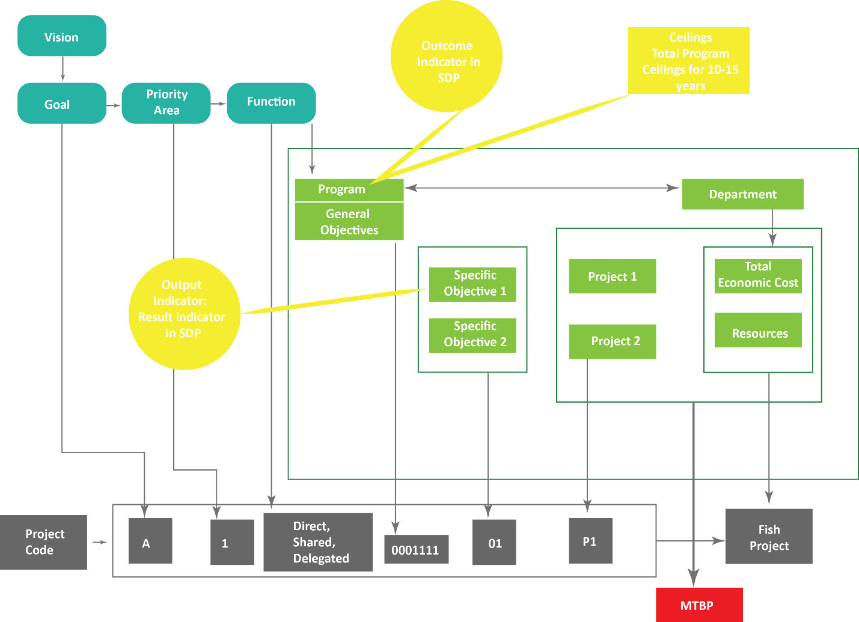
Fig. 1- Strategic Planning (Gjika et al, 2012)
The main priority areas can serve as guiding areas for further development of content-based scenarios within the LGU. The identification of these areas is based directly on the LGU functions as determined by law. However, it takes into account the fact that LGU’s strategic development plan covers more issues for development than it’s stipulated in its mandated functions. As such, the SDP is a more comprehensive document that goes beyond the political mandate of the LGU.
An objective defines what needs to be done, how much, and when. The program budget should contain expenditure programs. Each program should have a name, a description and a policy for which the performance indicators can be set as follows:
- program policy goals
- program policy objectives
- program outputs
- program activities
- program inputs.
An expenditure program can be defined as a meaningful and manageable set of activities, with outputs that contribute directly or indirectly (as inputs to other activities) to the achievement of policy objectives and policy goals.

2.3.3 Results
After the methodology was drafted, dldp has tried to diffuse this approach to the different government structures. Diffusion in this sense is defined as “the process by which an innovation is communicated through certain channels over time among members of a social system” (Berry and Berry, 1999: 171). Diffusion describes a trend of successive or sequential adoption of a practice, policy or programme. According to dldp1, dldp2, dldp3 and EXP 2, there dldp has established different channels of diffusing and transferring its knowledge. This is structured through the dldp Knowledge Management transfer and it comprises different approaches spanning from training, curricula development, coaching through direct support as well as the centers of competence formed by a network of different actors. Another strong point in the dissemination and knowledge transfer is the dldp approach for working closely with local authorities and enabling bottom up and trustful processes.
In addition to the manual for drafting SDP in conjunction with MTB according to EXP 2 was to develop also an electronic tool hence SDPeMTBP. According to EXP 2: “In the middle you have this “e”, this means we have also developed a financial plan tool for the medium term, on excel basis. This should facilitate the financial plan part of the medium term budget.”
Afterwards, according to EXP 2 and DLDP 1 the focus would be on improving also downstream processes such as implementation, budget implementation and then also reporting and audit supervision in order to close the cycle of financial management.
However, due to the reforms undertaken by the central government, most notably the Territorial Administrative Reform, it was almost impossible to continue with this line of activity. The context was such that LGU and central government were now concerned with the reform, thus dldp also had to reframe its line of activity. The TAR would be also followed up by a new law on the functioning and organization of local authorities as well as a new law for Local finances. In both cases dldp has been involved, especially in the latter, law on Local Finances, where according to EXP 2 and DLDP 1, they are involved in drafting a very important part of the law. In this context, given the previous experience of dldp in local finances, they are involved in developing the section of “financial management”. In this sense, considering the contextual situation in Albania, dldp has been quick in redefining and adapting to the circumstances, as well as using the existing knowledge and channeling it also through the legal framework. According to the SP1, dldp has a strong approach in trying to align its processes with the legal framework, and this case shows a clear example of that.

2.4 Functional Area Study
“The study of Functional Area in Albania” contains the methodology for defining 8 Functional Areas in 5 Qarks (Shkodër, Lezhë, Dibër, Kukës and Durrës), where dldp program operates. According to the interviews with dldp staff and experts involved in the development of the methodology, the study came as an internal necessity for dldp in order to identify new partners. Until phase two, dldp had worked in two qarks in northwest Albania (namely Shkodër and Lezhë). The main aim of dldp, which was trying to expand its area of influence to the whole northern Albanian region (integrating three other “qarks”, Kukës, Durrës, Dibër), at the time, was to find “new clusters rather than resonating nuclei” (DLDP 1) in terms of new municipalities that could become possible partners. Their previous experience in the phase 1 and 2, led to the conclusion that in order to have a greater influence, and to foster local development and decentralization, it was necessary not only to find the new partners, but to find clusters of partners in the new areas. Therefore, one the main criteria of this study became the functionality of the area, hence the functional area study.
Based on dldp report on the methodology of the functional area study, the term 'functional area' refers to the notion “that understanding a space – whatever the level it may be (municipality, region and so on) – should not be defined along administrative or historical lines, but based on how the different interactions happen within that space” (Bushati, B., et al 2014). This to show, for example, the way how it is used by its residents or in the basis of cooperation that happens between different governmental or economic entities.
In order to define the methodology, according to interviews with DLDP 1, EXP 1 and EXP 2, different case studies were taken into consideration from Switzerland and Germany (See appendix). However, the chosen methodology resembled mostly the Swiss approach of Agglomerations. According to EXP2:
“an agglomeration in Switzerland is an urban area, but these urban areas are very much fragmented, they are maybe a core city and then around it we have an outer belt and sometimes it goes over cantonal borders and maybe sometimes even across national border like for instance Basel or Geneva because they cross international borders. But they should cooperate at least, in Switzerland it is very difficult to come to mergers, we had some merging but it is very difficult because of the direct democracy. But the federal government came to the conclusion that these agglomerations are very important, 75% of population live in the agglomeration and not in the rural area, but in the agglomerations it is where GDP is produced, and the bigger problems are between these agglomerations so it is very important that they work more efficiently and that have a better collaboration. So that was a little bit the idea”
Afterwards, given the different contexts, as well as data availability, the methodology was adapted to work within the Albanian context. So, for the identification of a functional area some of the following criteria were used such as: where do people go to work (employment); where do they go for shopping (consumption), then it was about health (where do you go for health emergency); where do you go to school (education); finally, governance as well (do we already have areas where municipalities cooperate?). (EXP 1, EXP 2, DLDP 1). Thus, by to studying what is already taking place functionally would allow to these functional areas look like. And if there are potential centers within these functional areas, this could either become a core city or otherwise if merging was to take place this then should become the future municipality (EXP 2).
In order to define the functional areas in the five regions of interest, an analysis of several interactions amongst the inhabitants driven by the economic and services relations as well as the institutional interactions between the LGUs was carried out. The main methodological instruments for the analyses included desk review of existing and collected data, profiles and strategies at local and regional level; semi-structured interviews with representatives of the main Local Government Units and deconcentrated institutions, as well as focus groups with local and regional stakeholders.
Three main groups of indicators were used to carry out the analysis such as Economy, Services and Governance. The three groups had some main research questions, variables and indicators which not only aimed at identifying the location, but also the interaction and the movement of people and flows in this sense.
Table 2- FA study indicators (Bushati, B., et al 2014)
Economy | Employment | Consumption
Economy | Are there enterprises with a big number of employees attracting people from other LGUs? | The location of the biggest markets in the district/region.
Economy | Is there a substantial number of people living in one LGU and working in other LGUs? | The consumption attitudes of people. Where do people go to buy consumables or durable goods?
Access to services | Health | Education
Access to services | Location of the hospitals and biggest health centers. | Location of the secondary (general and vocational) schools
Access to services | The health facilities mostly used by people. | Movement of people towards secondary schools if in a different location.
Governance | Inter LGU Cooperation
Governance | Number of Inter LGU cooperations between two LGUs.

2.4.2 The process
Five teams worked in each of the five regions to prepare the report. The teams were coordinated and supervised by a research supervisor, with valuable methodological guidance from the University of Applied Sciences and Arts, Lucerne, Switzerland. The methodology prepared was revised, amended and completed via a series of workshops with the field teams to assure its appropriateness for the specific Albanian conditions. The research steps in each region and related products are explained in the following graph:
Table 3- FA study work methodology (Bushati, B., et al 2014)
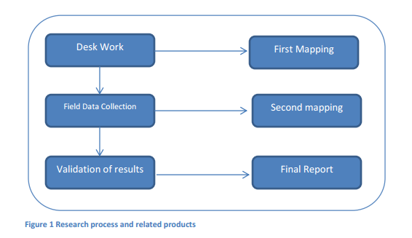
According to EXP 1 and EXP 2 the biggest challenge in the process of drafting the Functional Area Study was data availability and data collection. Most of the data were not integrated and not available at the required level. In addition to this, the second limitation was related with time, meaning that the studies had to be carried out in a relatively short time. Therefore, “an action research” methodology to a certain extent was carried out. By this is meant that firstly an initial overview of available data was collected via existing studies. This allowed for the service providers to identify data gaps as well as research gaps.
Afterwards, field data collection was conducted in order to fill the gaps via interviews, questionnaires and focus groups. In the end a ‘mapping’ of the territory was conducted, followed by different experts meeting between the dldp expert group and the service providers. This process allowed for continuous review of approaches and adaptation to the context and field situation with data gathered. Thus, it can be concluded that the methodological approach, the indicators and the variables were on continuous evolution based on the context. From a research point of view, given the above-mentioned limitations, time and data, this seems like a sensible approach to take with the study.
However, also as confirmed by two different interviews, DLDP 3 and SP 3, the methodology was unclear at the beginning. DLDP 3, also adds that themselves they were slightly unclear on the outcome of the study due to the conditionality of data. While, SP3, confirms that there was a mismatch between the terms of references of the project and the requirements that dldp had in mind. This led sometimes to a confusing situation between service providers and dldp on the product, which also had implications on the final product, as well as variations of the quality depending on the service provider. These can also be seen by the analysis of a sample of FAS where there are large differences between the different service providers in terms of the depth and interpretation of the materials, with some being purely descriptive in terms of identifying facts and a superficial description of flows, and others which took a more analytical and proactive approach.
The above is also confirmed by SP 1, who identifies the difference between the different service providers. According to SP1, due to the fact that the methodology was quite flexible and open to interpretation, the analysis and results were dependent on the quality, knowledge and previous experience of service providers. DLDP1 and DLDP3 also to a certain extent confirm this issue by saying that most service providers did not have the appropriate experience in order to carry out some of the more complex analysis.
However, in order to overcome some of the limitations, initially DLDP appointed five groups of service providers, one for each districts, with one of the main criteria being that they had a good knowledge and previous experiences in the local context. This can be considered as a strong approach in order to overcome data gaps as well as time limitations due to the fact that service providers had already a good knowledge of the area as well as established contacts with local authorities. Meanwhile, in order to overcome the methodological concerns raised above, the “action research approach” taken by dldp was a strong point in the process. In this sense, service providers were guided through the whole process. In addition, the discussions and seminars developed between all service providers, allowed also to achieve a better understanding of the process as well as to share experiences and knowledge. This is also confirmed by SP2, who values the process and the proactive approach that dldp took with the service providers.

2.4.3 The results of the Functional Area study
The functional area study was developed during a particular period regarding local government in Albania as the territorial administrative reform was being prepared on that time. Hence, besides creating a framework for the internal objective of dldp, i.e. finding new clusters of partners for the program, the study also helped in developing scenarios for the size and form of future municipalities, based on the criteria of functionalism.
Thus the results of the study focused on possible scenarios for the territorial structure of future municipalities and new clusters of partners for dldp. The later were also categorized into different typologies, with the three main typologies identified during the research. These typologies are quite possible can be found in other regions of Albania as well, although in the five regions the researchers found a high degree of volatility of the main feature of the FA in terms of population, surface, local income and population density. The three main typologies are described below:
- The concentric (Monocentric) model.
The concentric model of the functional area is especially dominant in the poorest, mountainous and isolated regions. The functional area overlaps with the border of the district. This tendency is clear in the regions of Dibër and Kukës, but also in some areas of Shkodër and Lezhë. The main features of this type of the functional area (FA) are:
- The area has one important center that is the town or the administrative center of the district. This is due to the economic structure of the area, the town as the only important market place, but also due to its importance as the place where the services are located. There are no other intermediate centers.
Fig. 2- concentric model (Bushati, B., et al 2014)
- The fu nctional area is stronger in the LGUs close to the FA center; the intensity of the linkages decreases when distance to FA center increases. Typically, this effect of inner cohesion corresponds with the population density, the urban centre has a (relatively) high population density, with the surrounding LGUs having also a medium-size population density while the rest of the LGUs far from the centre sparsely populated and have weak interactions. Strictly speaking, those LGUs are typically outside of the functional area; however, the still existing weak linkages are mostly with the FA centre.
- The polycentric model.
This type of FA is mostly used to describe the districts of Shkodër and Durrës. Those are the biggest districts in the area of the study with a high population density located in the western lowlands. The main features of this FA type include:
- The existence of a big regional centre with a strong inflow of new residents. Both cities of Shkodra and Durrës are capitals of their respective regions and are very important to the district and regions as economic centres.
- While the regional center is very powerful, there are also smaller sub-centers that serve as a center to their surrounding rural areas. In a way these areas have two centers: the big capital of the region but also the smaller town center of the area where people get some of the services and use the local markets.
- Since there is a dense interaction between the LGUs, the local boundaries do not match with the Functional Areas boundaries.
- The cross border model.
This type of FA is an option more than a first choice in most of the districts where it emerges as a solution. It might include areas across borders of districts, regions or even nations (i.e Montenegro in Shkoder and Macedonia in Diber). The main features for this type of FA:
Fig. 3 Polycentric Model (Bushati, B., et al 2014)
- It usually overlaps with the concentric model; the area might have two centers, one within its district and the other one across the district border. Further and more detailed research will be needed to investigate current and future trends of the area interaction.
- The cross-border area might be driven by shared traditions or new economic realities especially in the context of intensified international cross border cooperation intensification. In this second case the cohesion of the area is especially dependent on the development scenarios.
In addition to the results of the research, on its bases dldp developed a series of recommendations for the central government with regard to the TAR. Firstly, in terms of methodology, with this research, it was proven that it could be done within a relatively short timeframe. In addition, it offered to the central government a new criterion, which afterwards became very important such as the functionality for new municipalities. A study trip was also conducted in Switzerland in order to show and convince the central government with regard to the validity and the importance of the “functionality” criteria for the TAR. The research itself, came with different scenarios with regard to the division of the different municipalities for the 5 main districts that were under assessment. The above mentioned typologies, also served as a basis that could be used with regard to the new division (merging of municipalities). In this sense, also the rural-urban partnership, and the relationship between these two distinct typologies, was a key element.
Fig. 4- cross border model (Bushati, B., et al 2014)

2.5 Functional Area Program
The FA study as mentioned above, soon became an important element of the TAR. The dldp approach was afterwards taken by the central government and integrated with their already established methodology. The final result, in most cases reflected and was in convergence with the FA conclusion, with few exceptions due to political reasons or issues related to ethnic minorities, where other criteria were applied in order to be in line with European conventions for ethnic minorities. In addition, it became evident through the FA study that the newly formed municipalities would be faced very soon with several challenges coming from the reform ranging from organizational issues within the municipality up to service provision, economic development and infrastructural provision. Therefore, after the study of functional areas, according to DLDP 1,2,3 and EXP 1 and 2, it was necessary to continue with the project. “It felt like a job half-done” (DLDP1). Due to the transitory situation in relation to the territorial administrative reform it was very difficult, not to say impossible to work with local authorities in drafting strategic spatial plans or general local plans (as defined in the territory planning legislation). Therefore, dldp opted for an intermediate document, which would take the functional area study into another level – that of the strategic thinking. Due to the fact that is was still unclear the way that the new municipalities would look like, dldp aimed with FAP to create a document with projects focusing on cooperation within the functional area. Secondly, once the new municipalities would be formed it would help the new local authorities and mayors after the elections to get a better understanding of their territory and needs for investments. Subsequently, the functional area program was developed.
DLDP drafted eight FAPs (eight areas): Malësi e Madhe, Lezhë, Durrës, Shijak, Kukës, Tropojë, Dibër and Mat during October 2014 – April 2015. The work was implemented by eight organizations that worked intensively in the field during these months, and it was based on several general guidelines that were enriched step by step by the experience in the field and with the relevant tools.
FAP aimed at an in-depth analysis of the main economic sectors and public services that are provided in the area and the identification of a group of projects that respond to both long term vision of territorial development and quick interventions that serve the consolidation of the new local unit. FAP, besides being an intermediate step towards a long-term development strategy of the new Municipalities, was also a different methodology of reading the territory not as a sum of territories of former local government units but as a dynamic organism that interacts in many aspects and continuously and, among other things, needs aimed public interventions to facilitate this interaction. In addition, it was the first attempt of drafting a strategic document, albeit the need for both long-term and short-term objectives, for the new municipalities.
The FAP was divided in two main parts, an analysis of the functional area and then Part B comprising the program for development. The analysis focused on three main topics, following a similar line with the Functional Area Studies and building on it. Thus, the first part comprised a general description of the area, an in-depth analysis of the economy and then public services.
- General Description of the Functional Area
The objective of this chapter was to give an overview of the functional area, to create an immediate idea of the territory, people, culture and dynamics on the Functional Area though the description of simple yet basic data and indicators aggregated at the FA level. This introductory chapter will be mostly based on desk reviews of previous reports and data.
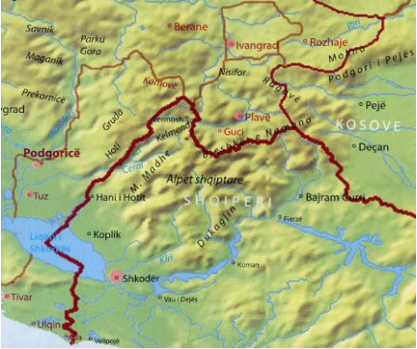
Fig. 5- General Description (FAP Malesi e Madhe, dldp 2015)
This chapter also included the review of different strategies, plans and programs developed for the individual administrative units of the functional area, regional and national plans. In addition, it was based also on statistical data from INSTAT and other sources, in order to create the overall framework and understanding of the FA. Some of the main topics of this chapter included a general description of:
- Geographical location where the area is located, its surface.
- General data on the FA climate
- History, culture, traditions, main attractions
- A short historical overview of the area (i.e. historical facts of the inhabitation of the area and a short overview of its development)
- Description of cultural ties, traditions, ethnography, religion, the main attractions; what is the area known for, etc.
- Data on the population of the FA (its weight in the region; its comparison with national/regional averages/ population density)
- Data on population during the last 10 years as per the INSTAT data and civil registry office, if deemed relevant
- Migration trends to and from the area
- Population in the composing administrative units
- Urban-rural population and its changes
- Key data on the structure of the population and its families; age structure etc.
- Access to the FA, main distances and transport conditions from the capital, main ports, airports, major highways
- Environmental Resources (main mountain ranges, plains, rivers, lakes, forests etc.)
- Composing Administrative Units

- Economy of the functional area.
The objective of this chapter was to provide data and analysis on the current status of the economy and its development potentials for the functional area. The idea was to focus on key indicators of the economy; understanding its most important sectors and sub-sectors in the FA; identifying challenges and respective recommendations for improvement. A special emphasis was given to the identification of the dynamics of economic interaction within the FA as a tool to better understand its drivers and potentials in the area. The analysis of the economic characteristics of the Functional Area aimed at providing an understanding of the structure and nature of the economy of the functional area such as the main branches of the economy in the FA as well as the labor market. Based on the analysis done and consultations, 2-3 more important or potential economic sectors were analyzed in more detail. The analysis conducted included issues such as:
- the priority sector at national, regional and FA level.
- Identification of the problems and needs in these sectors; identification of the most important (current and potentially) priority sub-sectors.
- evaluation of the market opportunities for the priority sector.
- analytical recommendations for linkages of the sector with other sectors of the FA economy.
Meanwhile the labor market analyses provided the workforce profile, highlighting skills, shortages etc, Employment / unemployment age structure, level of education, employment by economic sectors, public/private, main employers and their location, educational and vocational training available for the inhabitants of the FA, employment / Underemployment in agriculture. In addition, social aspects were also discussed in this section referring to issues of poverty, gender, disparities etc.
As a conclusion of the chapter on economic development, a summary of the economic features of the FA was given.
Fig. 6- Example of Economic Interrelation Analysis, Lezhe Municipality (dldp 2015)
The analysis draws largely on the earlier studies prepared for the functional area research. Some of the indicators used here focused on employment patterns, main employers in the area, commuting pattern, consumption etc. The section concludes with an overview of the functional area its linkages, core FA, importance of the sectors, main economic centers, peripheral areas in the FA underdeveloped potential areas and recommendation on the main economy sectors to be further analyzed.
Data collection focused on Local Economic Development strategies, profile of the local/regional economies, data collections from the government offices; chambers of commerce; local/regional development agencies. National and regional sectoral strategies were also consulted when developing this analysis. In addition, other methods to collect information were used such as direct interviews and/or focus groups. The findings and recommendations were afterwards discussed in SWOT analysis and objective setting workshops.
- Mapping the local services in the functional area
The objective of this chapter was to provide a map of the situation of the provision of local services in the functional area. It focused on the key services provided directly or as a shared function by the Local Government. The analysis served to understand and identify the main services and their existing or potential problems as well as to identify key recommendations for the improvement, extension and optimization of the service offered for a substantial number of the inhabitants of the FA. The key services that were analyzed in eight LGUs in dldp process include in any case the following three services:
- Water Supply and Sewage
- Roads and public transport
- Waste Management Obviously
- Other services depending on their weight in the FA
With regard to water supply and sewage the analysis focused on issues such as service coverage, description of FA infrastructure, service management/financing. Meanwhile recommendations focused on organizing/integrating the service in the new unit, prioritization of investments, service management and financing.
The analysis for roads and public transport focused primarily on issues of access, the present situation and the need for investments in transport/roads, organization of public transport inside and outside FA as well as management and financing of roads/transport. Recommendations were focused as a response to the challenges in organizing and integrating the service in the new Local Unit, prioritization of investments, management of the road network and improvement of public transport service.
Waste Management analysis focused on the present situation of waste management in terms of waste generation, collection and coverage, service provision infrastructure, service management and financing.
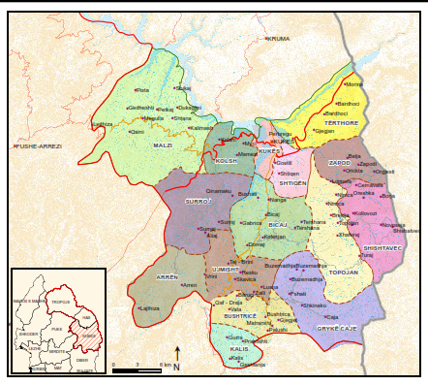
Fig. 7- Mapping local services (FAP Kukes, dldp 2015)
In addition, it was associated with an assessment of feasibility for the service integration into the new unit in terms of technical assessment with mapping of the main situation and drafting several potential schemes, economic assessment with cost estimates for each scheme and proposal of tariff strategy, organizational aspect with processing the best legal and organizational scenarios for service provision.

2.5.2 Results of the FAP
The functional area development program was followed by an identification and preparation of a bundle of priority projects of the FA. In the first phase, a high number of projects were identified, mainly deriving from the information gathered during the analysis. In a joint discussion in the FA forum, all the members were invited to present project ideas and afterwards in a separate workshop all the projects were discussed. Through the prioritization criteria, a group of 12-15 projects were afterwards further developed into more complete project documents. In general, projects were grouped in three areas such as economic development, public service projects and quick start projects.
The economic development projects varied in focus on the priority economy sectors as identified in the FAP and aimed at positively impacting the private sector development, public private partnerships, strengthening of SMEs, improvement of the business climate, assistance to the business start-ups as well as marketing of the territory etc.
Public service improvement projects aimed at the improvement of public services under the competency of the LGUs in the wider functional area as well as the identification of actions that will help in delivering better services to the FA citizens. These projects included infrastructure improvements such as roads and public transport, water supply and sewage, waste management, social services project, shared functions such as improvement in the education and health care infrastructure etc. Meanwhile quick start projects typically derived from the recommendations of the governance analysis and aimed at quickly mobilizing for the improvement of administrative services.
However, although the projects were divided into three main strands, their intention was to promote more than one of the categories, thus increasing their cumulative effects in the FA. For each project, a proposal sheet was prepared which gave more detailed explanations on the aims and objectives of the projects, the desired outcomes and relevance for the LGU as well as possible sources of financing. With regard to the latter, it is worth to mention, that dldp also assigned a grant for the quick start projects in order to implemented. According to interviews with dldp experts as well as service providers, this was a good tool to help also in building the cohesion for the newly formed LGU.
The FAP were also intended as an intermediary strategic tool not only for the local government but also to offer some support in terms of strengthening the TAR and identifying projects that would help in building cohesion. In this sense, it is important to mention, that dldp offered also some recommendations to the central governments of steps to take in strengthening and implementing the TAR. One of the proposals, which were not fully taken in consideration (dldp 1) was the provision of a transitory fund which would support municipalities. Meanwhile, one of the main project proposals of the FAP was also to develop “one stop shops” in municipalities which would offer different services to the citizens. Some of these were financed, and still being financed by dldp in the municipalities where the FAP-s were drafted. Meanwhile, this idea was also taken up by other donor parties operating in different parts of Albania which are replicating the project and dldp best practice with “one stop shops”.

2.5.3 Territorial Development Strategies
Once FAP were finished, dldp was trying to proceed with the support for drafting financial management instruments for the new municipalities, accordingly MTBP. However, based on previous experiences with SDPeMTBP, and the work ethos of dldp of working within the legal instruments and framework a strategic framework was necessary to serve as an umbrella for the MTBP. Thus, through various consultations with the Ministry of Urban Development and the National Territorial Planning Agency, it was agreed that the FAP contained parts of a territorial development strategy. Hence, dldp started to support some of the municipalities, which already had FAP, to turn them into Territorial Development Strategies. This process is also confirmed by the interviews where NGP 1, says that a series of meetings were conducted in order to extend the FAP documents into territorial strategies. In addition, also a gap analysis was developed in order to identify the different aspects of FAP that had to be upgraded and expanded in order to fulfill the criteria for a Territorial Strategy.
To continue the work with the Territorial Strategies, dldp in most cases used the same service providers, which initially prepared the FAPs. In this case, the process also required the service providers to link these territorial strategies with the mid-term budget. In order to draft the territorial strategies, the service providers were based on the Manual for Strategic Planning and Mid Term Budgeting (developed by dldp), on the legislation on territory planning and development and on the Manual for Territorial Planning and Development (prepared by Co-PLAN, in cooperation with NTPA, under the framework of the USAID Planning and Local Government Program).
However, even in this case some similar trends to FAP development can be seen. In most cases, due to time constraints, budgeting and ability of the service provider in territorial planning the quality of the documents varies. In most cases, although there are attempts to develop spatial analysis as well as develop the strategy from a more territorial perspective, it can be noticed that the spatial component is quite weak. Thus, in some cases the territorial strategies are purely descriptive rather than analytical, building on existing data.
A clear example in this case is the metabolism analysis and the analysis of the 5 main territorial systems. Based on the territorial strategies for the 5 municipalities, this element in most cases is purely a descriptive one, whereas by law, it needs to have a more quantitative and spatial approach. Below, this approach is shown at the national level.
Fig. 8- The Metabolism of food in Albania (Brugman G., Persyn F., 2016)
The territorial strategy requires GIS, which is based on spatial data, however, given the condition with data availability in Albania, most of the information needs to be gathered or generated from the beginning in order to create the base map. Therefore, not acknowledging this component of data gathering and data availability, combined with a lack of experience and clarity, the territorial strategies developed fulfill most of the legal requirements but not all of them.
The difference in the product can also be deducted from the lack of previous experiences in spatial/territorial planning. In addition, beyond the lack of capacities from some of the service providers another aspect is also that dldp was not clear itself in terms of methodology and the amount of work required in order to draft a “strategic spatial plan” (Territorial Strategy) in comparison to a “strategic plan” which is dldp’s main area of expertise.
According to the interview with dldp3, it is admitted to a certain extent that in some cases also dldp was unclear in terms of the methodology and the requirements for a territorial strategy. The time-funding ratio according to the work ratio that had to be conducted in order to fulfill the law requirements for a territorial strategy were not fully evaluated. Therefore, also from the territorial strategies developed, it can be seen that there are a lot of spatial information and data which are missing.

Chapter 3- Impact of Strategic Planning

3.1 Impact at National Level
A key impact that dldp has on a national level, was the inclusion of FAs as a criterion in the territorial-administrative reform. A process that was initiated for internal purposes had a positive externally irradiating effect at government level.
The cooperation that dldp has established at national level in terms of planning, is important as it provides a new channel of communication between LGUs and the national planning institutions. This channel of communication is complementary and supportive to existing relationships, especially because it also contains valuable knowledge.
Instruments wise, FAPs and Territorial Strategies Developed by dldp during phase 3, do not fully reflect methodological as well as content requirements of the territorial planning legislation. This is natural, given the purpose for which these were drafted, but on the other case it was also understood that regardless the initial value, the Functional Area Programs could not be applied further. dldp is interested in supporting local governments to become stronger (in terms of capacities and finances) and it recognizes that this can and should be achieved under an existing legal and institutional framework that has gone through (participatory) reforms and is now widely accepted.
In addition, it can be said that the FAP, based also on interviews and the discussions during the focus group served as an intermediary tool. Some of the projects identified under the programing of FAPs are seen as important in pushing the TAR forward from an organizational and functional institutional perspective. In this sense, especially the “one stop shops” developed at the municipalities are now accepted and being applied also in other municipalities outside the area of influence of dldp.
On the other hand, linking Strategic Development Plans and later on Territorial Strategies with MTBP is a strong argument. The Ministry of Urban development recognizes the approach and dldp is currently applying it as part of the assistance is providing to 3+2 municipalities in terms of spatial planning. Based also on the interviews, there seems to be a general consensus that the combination of strategies with the mid-term budget is necessary.
However, the method municipalities chose to combine MTBP with GLP cannot be imposed. So, the planning legislation makes a clear definition on the preparation of the capital investment plan as an inherent tool of territory planning, because it allows for financial programing in terms of infrastructure development. CIP for GLP may have a time span of 3-15 years, with detailed short-term indications (3-5 years) and looser indications for the remaining period. CIP reflects the GLP objectives, which do not fully coincide with the MTBP policy objectives. The MTBP policy objectives contain the GLP and CIP objectives, but include other objectives as well, related also to administrative issues. This is because MTBP is primarily a financial management tool, while CIP is both a financial management and fiscal policy tool, focusing exclusively on infrastructure and public works investments. MTBP has a time span of 3 years only (annually revised) and includes only fundable projects, i.e. actions for which funds exist (either local, or national sources). CIP includes all infrastructure/public works actions needed for territorial development, regardless of the availability of funds. Because of the latter, CIP includes also financial sources forecasts. Having said this, the conclusion is that it is not possible to replace CIP with MTBP, or vice versa. In fact, an Albanian municipality has to prepare both, because it is needed and because both are legally required. Therefore, it is in the genuine interest of the municipality to make sure that both instruments are compatible, complementary and in harmony.
Currently dldp is providing assistance to the Ministry of Finances in the process of drafting a new law on local finances. Thus dldp experience as described above, is important and valuable in giving inputs on how strategic planning and financial management can sustain one-another, without though subverting the respective values.

3.2 Impact at the local level
Local level impacts of dldp planning instruments approach is rather short term, but clear for the time being. A quick and direct impact is the preparation of a number of planning instruments (6 SDPs, 8 FAPs, 8 Territorial Strategies, 5 GLPs). However, the main work of dldp is focused on local development and this is where the major impacts are felt and seen.
The SDPeMTBP approach and the manual offer/ed a general framework for all municipalities, which can be applied country wide (not only in the dldp area of influence) for the development of strategic planning and linking them with the budget. In this sense, it has played a direct impact in terms of increasing local capacities within this pillar. It is also important to say, that within the framework of SDPeMTBP and the work conducted by dldp an indirect impact can also be considered the influence for local authorities to think in a strategic way as well as to acknowledge the importance of strategic planning as an instrument for better governance. This is confirmed also by SP2, who argues that through the processes established by dldp within the centers of competence, municipalities become aware of the importance of such instruments, and try to “copy” the practices that others have established. In this sense the exchange of experiences provided by dldp helps also in raising awareness of the importance and with regard to the processes of strategic planning. However, due to the territorial reform as well as legal changes, an update of the material would be necessary to reflect the new circumstances.
The development of the Functional Area Study and afterwards the Functional Area Program offer a good basis of information and general analysis for the newly formed municipalities. In discussion with representatives of the municipality of Mat and Durres it was said that these two documents formed a basis for initiating their work as well as getting acquainted with the new territory. In addition, the work done by dldp in disseminating these products before elections has had an impact. In most cases, candidates from the different the different parties used the FAS and FAP in their election campaign programs. This is confirmed by the dldp experts, service providers as well as municipal officials. In some cases, the FAP were completely converted in the electoral campaign programs. In addition, the data and recommendation from FAS and FAP also form a good basis for future strategic documents.
The quick start projects, identified as part of FAPs, are also a direct impact that the dldp activity has had at the local level. In this sense, a key component, mentioned also in the previous section, is the establishment of the “one stop shops” at the different municipalities. This is also confirmed by the local representative of the municipality of MAT which values the establishment of such unit at their municipality and sees it as an opportunity for improving service delivery at the local level.
The recommendations given through the FAS and the FAP with regard to the institutional organization of new municipalities can also be considered to a certain extent as an impact. In some cases, the municipalities have taken on board these recommendations in order to structure and organize their work. So it can also be seen as an attempt of strengthening the territorial reform.
Lastly, dldp participatory practices and in close cooperation with local government (hand-on approach) do have an impact. It was a general consensus among the interviews that this is one of the strongest points of the dldp program. Working closely with local government has also helped the latter to open up new channels of communication with the higher tiers. The direct presence of dldp and strong collaboration with local authorities has increased their trust towards the program and the acceptance of procedures and methodologies. Thus, this approach needs to be maintained and further enhanced especially due to the outcomes of the territorial reform and the difficulties that municipalities face. In addition, the close cooperation also helps in bringing together the different municipalities in the region and fostering partnerships and inter-municipal cooperation on specific issues.

Chapter 4- Knowledge Management DLDP
The dldp Knowledge Management has developed accordingly to the expansion of dldp activity both content and territorially. There is a clear synergy between the work conducted on field and the organization of the materials in the KM. It can be said that dldp takes special care on transferring the knowledge created through different channels of communications.
The centers of competence are one of the most recognized achievements in terms of knowledge transfer and dissemination. They are established in the 5 main districts and are composed by different municipal representatives of the municipalities. The centers of competence conduct training activities, best practice exchange between the municipalities on common issues as well as discussion of everyday challenges. In addition, study trips are also conducted through the centers of competence. The importance, results and positive impacts of these centers are not only confirmed by dldp representatives (dldp 2, dldp3), but also from the service providers (SP 2) and the municipal representatives. Besides capacity building, the centers of competence also serve as a platform for building partnerships between municipalities for future cooperation.
In addition to the centers of competence, dldp supports municipalities in increasing capacities through training. Different curricula have been prepared throughout the dldp activity and they are always in evolution. Besides the training which is conducted through the centers of competence, dldp has also an agreement with the School of Public Administration in order to disseminate and transfer knowledge. According to dldp 2, its activity does not stop at training but another important component is also coaching. Working closely with municipalities in drafting and developing instruments as well as solving problems is a strong point. dldps established channels of working with the municipalities is a strong point. Thus, this type of partnerships should continue to be enhanced. Especially, considering the circumstances over the last 3 years, due to the different reforms, dldp has shifted part of its attention towards central level government which to a certain extent was understandable. However, since its main aim is local development, dldp needs to re-focus strongly at the local level.
The dldp Knowledge Management framework is divided in four main pillars reflecting dldp areas of work such as:
- Public Finance Management and Strategic Planning
- Waste Management
- E-Governance and Communication
- Fund Access
These four pillars are well integrated within the dldp website and are accessible for all. Below a short description of each of the pillars and the channels used by dldp to spread and disseminate the knowledge. It is worth to mention that only the first pillar is the object of this study.
Public Finance Management and Strategic Planning
This pillar forms the basis for knowledge management in terms of Public Finance Management and Strategic Planning. The pillar is based on the SDPeMTBP approach as well as the more recent experiences with the FA studies and the FAP. In addition, due to the fact that dldp has expanded its work also into General Local Planning, experiences from this process should be reflected in the KM. In this sense there could be a division of this pillar in two main areas such as Strategic Territorial Planning (1) and (2) Strategic Planning and Public Finance Management.
Waste Management
The knowledge package aims to build the capacities of LGUs to provide efficient waste management services based on good practices and strategic objectives for the sector. The overall policy framework is based on the National Waste Management Strategy and Integrated Waste Management Law (2011), Regional Waste Management Plans (where existent) as well as successful local policies and practices.
E-Governance and Communication
The knowledge package aims to guide LGUs in adopting practical uses of information and communications technology in order to support more transparent, efficient and effective local government operations, more client oriented public service delivery and more informed and engaged citizens, in line with relevant national strategies and good practices. dldp has built a good experience in this topic and it can be further enhanced with the new planning and municipal legal changes. However, also from interviews, it can be seen that the dldp has a strong expertise and experience in bottom up local activities.
Fund Access
The knowledge package aims to strengthen the capacities of LGUs on inter-LGU and cross-border project development and implementation. This pillar is based on the "National Strategy for Development and Integration", Regional Strategic Plans as well as successful local policies and practices. Anyway it can be improved also by adding further information on the now approved General National Territorial Plan, the IPA cross border programs such as Albania-Kosovo, Albania-Montenegro and Albania- Macedonia.

Chapter 5-Conclusions and Recommendations
Over the last 4 years, dldp strategic planning approach and instruments have evolved rapidly in order to respond to the different reforms taken in Albania. Besides the expansion of the different instruments, dldp area of activity has expanded as well from two districts to five. The coherence between phase 2 and 3, considering the light of events, has been smooth and continuously evolving.
During phase 2, SDPeMTBP was developed as a methodology to link strategic planning with budgeting. This is a strong approach, which shares general consensus by many. In phase 3, due to the territorial reform, it was very difficult to continue with the same approach as the conditions could not allow it. In addition, dldp at the time expanded its area of influence to 5 different qarks. The impacts of SDPeMTBP as a strategic planning instrument were:
- Offered a general framework for mainstreaming strategic planning activities
- Linked strategic planning activities with budgeting
- The strategies drafted through this instrument served as best practice examples
- Increased awareness at the local level with regard to the importance of strategic planning as a tool
What started as an internal exercise by dldp to find new clusters of partners, the functional area study, afterwards became an instrument which impacted also the Territorial Administrative Reform. In this sense, dldp had a direct impact by adding a new criterion, the functionality, to the criteria that were being used by the government for the TAR. So the main impacts of the FA study:
- Offered a basis for territorial Information and Analysis
- Functionality became a criterion for the territorial administrative reform
The FA study, afterwards evolved into FAP, which would serve as an intermediary strategic programing instrument. The FAP were associated with development scenarios for the clusters of municipalities and also offered a series of projects which aimed at local development. In addition, short-term, quick start projects, were also proposed and afterwards funded by dldp. The main impacts of FAP:
- Basis of information and analysis for other strategic planning documents and processes
- Territorial Information
- Through dissemination, FAP became part also of election campaign programs
- Quick start projects identified and financed by dldp (one stop shop)
- Offered recommendation for Institutional Organization and Functioning
Afterwards, dldp engaged with the Ministry of Urban Development in order to turn the FAP into Territorial Development Strategies. Although, from the gap analysis that has been conducted by dldp, the FAP resembles some parts of the Territorial Strategy, they are not the same. In addition, the results of the drafted strategies do not fulfill all the legal requirements, especially, due to different constraints, they lack in the spatial aspect of a territorial development strategy. Therefore, this initiative was expanded by also drafting Local General Plans linked with MTBP. Currently, dldp is supporting the drafting of five LGU plans.
As it was argued in this report, strategic territorial planning and strategic planning are similar but not the same process, although at times can be merged, they cannot substitute each other in terms of depth and breadth. The Territorial Planning reform, by embedding the strategic planning approach in the process, has enabled planning to be more flexible despite it statutory nature. Still it cannot have the same flexibility as the strategic planning process offers and, has a more territorial scope when compared to strategic planning which is broader. As such, Strategic Planning more than the product (which are legal requirements in the case of Territorial Plans) is framework that enables the local governments to use strategically its resources to achieve well defined objectives. As such, strategic planning cannot be considered closed once the GLP-s are drafted and it will be important for dldp to continue support LGUs to continue working in a strategic planning framework. Furthermore, apart from an overall strategic plan (city development strategy) or a territorial strategy, it is normal for LGUs to have even sectorial strategies if the need to pay special attention to a specific sector (see Appendix 2). Yet, it is important that all strategies are translated in a comprehensively into medium term budget programs and capital investment plans.
dldp knowledge management framework is strong and it uses different channels to diffuse policy transfer and knowledge. The mixture of channels allows not only for knowledge to be generated but also for learning processes from the different actors. Here, the centers of competence combined with coaching are two of the main instruments which have a very high impact.

5.2 Future short-term and mid-long term
Based on the analysis as well as on the interviews there are four main recurring themes which can be used as action areas for the future by dldp such as “strategic planning”, “visible projects”, “capacity building” and “monitoring”.

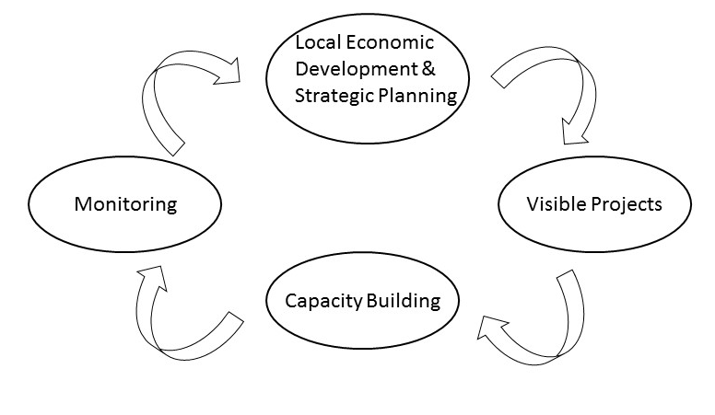
Fig. 9 Themes for future actions

Short-term (2017-2018)
In the short term dldp should focus on the completion of the GLP combined with MTBP. This is a delicate process which needs a lot of attention in order to be successfully completed and thereafter adopted by local government and approved by the NTC.
Meanwhile, dldp has asked the service providers engaged in drafting the local plans to also draft a report for increasing institutional capacities in territorial planning and management. These reports should be carefully assessed and used afterwards to shape the support for the LGU in order to implement these plans. In addition, according to EXP 3, dldp needs also to start moving forward in terms of developing a methodology for monitoring the implementation of the GLP. This can be done in parallel to the GLP drafting process. In addition, at the end of the drafting process of the GLP an assessment should be conducted highlighting the different aspects of the process. This can serve for several purposes such as identifying some of the challenges, identifying future support areas for dldp as well as giving recommendations to central and local authorities with regard to the process. In addition, the knowledge created through this process should become part of the KM framework of dldp.

Mid-Long term (2018-…)
With the completion of the GLPs, the strategic planning framework for LGU still cannot be considered complete. There are other issues which cannot be covered by territorial planning, hence dldp can support and complete this process.
The dldp aim is focused on local development and decentralization, thus in this case, strategies can be further developed for issues such as local economic development or service provision. The FAP in this case, resemble also Local Economic Development Plans which should be further explored by dldp. This view is also supported by EXP 1, who says that dldp can and should focus on local economic development by Drafting sectorial strategies for local economic development in exploring new instruments of income generation for municipalities, i.e. for own independently raising own revenues; explore PPPs in the area of public services and economic development.
Based on the above, cross border cooperation, and access to EU funding can be another important asset that can be further developed by dldp in the mid-long term. Most municipalities where dldp operates show features of shrinkage, in terms of difficulties of economic and social development, as well as they are also within the framework of the different cross border cooperation programmes such as Albania-Montenegro, Albania-Kosovo and Albania-FYROM. Thus, this can be associated with the increase in capacities for project proposal writing which is still a big challenge for LGUs. These new skills can be used both internally, for profiting from central government schemes such as the Regional Development Fund, and externally for accessing funding from cross border programs.
Increasing capacities in monitoring is another area which should be at dldp attention. Most plans will face challenges during their implementation phase, therefore it is imperative to support monitoring mechanisms. Some areas include:
  - Monitoring of spatial planning implementation and support to municipalities that have developed GLPs for employing internal processes of continual improvement, including the territorial reports required by law.
  - Monitoring of budgets, especially with a link to spatial planning and continues inclusion of the GLPs proposals in the MTBP frame.
  - Monitoring of the impact of dldp methodologies
Another issue which was raised by most interviews was also that dldp needs to focus in some visible projects. These can be pilots or larger projects within a greater partnership between local and central government. These projects could focus on different issues such as:
  - Projects in economic development
  - Projects in services
  - Projects in infrastructure
The KM framework of dldp needs to be updated with the new situation, post-TAR, as well as with an evolving legal framework. In this sense, the channels of dissemination that dldp uses are strong, thus centers of competence, coaching and training need to continue. However, new curricula need to be developed in order to respond to the new challenges. Part of these curricula could include, drafting/updating the SDPeMTBP approach to also reflect the new conditions with the municipalities.
It is important however, in this sense to preserve the flexibility as well as the non-statutory approach of strategic planning, and not to necessarily merge it with strategic spatial planning. These need allow flexibility for local authorities to respond to evolving and more dynamic challenges that they face. The approach here should be a combination of projects with new curricula in order to increase institutional capacities in dealing with this issue. Lasty, within the framework of cooperation within LGU, dldp should continue to foster the partnerships and the trustful relationship created. It was shown that the dldp has been able to establish channels of communication between local and central government beyond existing and formal ones, thus this approach should continue. dldps strength as a program is by working closely with LGU and this is an asset which needs to be preserved.

Literature
Albrechts L (2004) ‘Strategic (spatial) planning reexamined’, Environment and Planning B: Planning and Design, vol 31, p 743-758
Aliaj B, Dhamo S, Shutina D (2009) “Midis Vakumit dhe Energjise”. Botime Afrojdit, Tirane
BBR (2000) Raumentwicklung und Raumordnung in Deutschland, (online) available at: http://www.bbr.bund.de/BBSR/DE/Veroeffentlichungen/Abgeschlossen/Berichte/2000_2005/Downloads/KurzfassungROB2000.pdf;jsessionid=D85722F6303ACD2DBF8DA80F781B0D0B.live11291?__blob=publicationFile&v=3 (last accessed, December 2016)
BBR (2000) Spatial Development and Spatial Planning in Germany, (online) available at: http://www.bbsr.bund.de/BBSR/EN/Publications/CompletedSeries/Berichte/2000_2009/DL_Berichte7.pdf?__blob=publicationFile&v=3 (last accessed, December 2016)
Bennett, Colin. J. (1991) ‘Review Article: What is Policy Convergence and What Causes It?’ British Journal of Political Science, 21: 215-233.
Berry, Frances Stokes. and Berry, William. D. (1999) ‘Innovation and diffusion models in policy research’, in Paul A. Sabatier. (ed) Theories of the Policy Process, Boulder CO., Westview Press
Bushati B., Karakaçi V., Pfaeffli, F., (2014) Study on the Functional Areas in Albania
Bryman A., (2008) “Social Research Methods”, Oxford University Press, ISBN: 9780199202959
Bryson, J.M (2004) Strategic planning for public and nonprofit organizations: a guide to strengthening and sustaining organizational achievement. Jossey-Bass, San Francisco
Cities Alliance (2005) The Impact of City Development Strategies, (online), available at: http://www.citiesalliance.org/sites/citiesalliance.org/files/cds-impact-study-final-report-august-11-2005%5b1%5d.pdf. (last accessed, December 2016)
dldp (2013 Log-Frame
dldp (2015) Metodologjia per Pergatitjen e Programit te Zonave Funksionale
dldp (2015) Rekomandime bazuar në gjetjet e konferencës “konsolidimi i reformës administrative dhe territoriale: praktika dhe mësime” dhe pilotimin e modelit të “zyrave të integruara me një ndalesë”
dldp (2015) Updated Programme of Operations of the Decentralization and Local Development Programme
dldp (2015) FAP Malesi e Madhe

dldp (2015) FAP Lezhe

dldp (2015) FAP Kukes
dldp (2015) Revised logframe – post mtr- dldp Albania
Dldp (2016) Revised logframe – additional support for general local plans – dldp albania

Dolowitz, David. (1997) ‘British Employment Policy in the 1980s: Learning from the American Experience’, Governance, 10 (1)
Dolowitz, David. & Marsh, David. (2000) “Learning from Abroad: The Role of Policy Transfer in Contemporary Policy Making”, Governance 13 (1): 5-24.
Dolowitz, David. & Marsh, David. (1996) ‘Who Learns from Whom: A Review of the Policy Transfer Literature’, Political Studies, 44(2): 343-57.
Dühr, S.; Colomb, C.; Nadin, V. (2010) ‘European spatial planning and territorial cooperation’ London: Routledge
Faludi 1999, “Patterns of Doctrinal Development”. Journal of Planning Education and Research, vol 18 (4), 333-344
Friedmann J (2005) “Globalization and the emerging culture of planning”. Progress in Planning, vol 64, 183-234
Gjika A., Mihali A., Kokona D., Karakaçi V., Ademi V., (2012) “Long and Medium Term Strategic and Financial Planning, DLPD, Shkoder, Albania
Ikenberry, G. John. (1990) ‘The International Spread of Privatization Policies: Inducements, Learning and ‘Policy Band wagoning’’, in E. Suleiman & J. Waterbury (eds.) The Political Economy of Public Sector Reform and Privatization, Boulder: Westview Press
Ministry of Urban Development (2014) Policy Paper on Territorial Planning and Development”, (online) available at: www.zhvillimiurban.gov.al , (last accessed, December 2016)
Mintzberg, H. (1994) The rise and fall strategic planning. The Free Press, New York, 1994
Newman P., Thornley, A., (1996) Urban Planning in Europe, Routledge, London and New York, ISBN 0-203-73618-4
Pike A., Rodrìguez-Pose A., Tomaney J., (2006) Local and Regional Development. Routledge; London, ISBN: 978-0415357173
Rose, Richard. (1993) Lesson Drawing in Public Policy: A Guide to Learning Across Time and Space, Chatham, N.J., Chatham House.
Wilkinson, G. and Monkhouse, E. (1994) Strategic planning in public sector organizations. Executive Development 7(6), 16-19, http://dx.doi.org/10.1108/09533239410071878,

law nr.7572, dated June 10, 1992 “On the organization and the functions of the local government
the law nr.7608, dated September 22, 1992 “On the prefectures”
Law No. 8405, ‘On Urban Planning’ (1998)
Law of 31/07/2000 “On the Organization and Functioning of Local Governments in the Republic of Albania.”
law No.9936 of 26/06/2008 “On Management of Budgetary System in the Republic of Albania”
Law no. 10119 “On Territory Planning” (2009)
Law no. 107/2014 “On territory planning and development (2014)
DCM no. 408/2015, the development regulation; (2015)
DCM no. 671/2015, the planning regulation; (2015)
DCM no. 1096/2015, the public space regulation; (2015)

Appendix 1- CENTRAL PLACE APPROACH (GERMANY)
Central Place Theory (CPT) is a theory which was developed as an attempt to explain the spatial arrangement, size, and number of settlements. The theory was developed during the 193Os by Walter Christaller who was studying the settlement patterns in southern Germany at that time. The basic idea of this theory is that goods differ in their degree of scale economies relative to market size. Large cities tend to have a wide range of goods, whereas small cities provide only goods with low scale economies. Naturally, small cities are in the market areas of large cities for those goods that they themselves do not provide. This theory, afterwards has become a “planning doctrine” which has shaped the German Spatial planning system and policies.
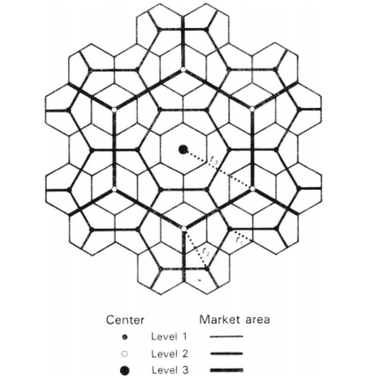
Fig. 10- Hierarchy of Centers
In Germany, planning occurs within a decentralized decision-making structure and a strong legal framework, associated with the Basic Law (Grundgesetz) of 1949 (Newman and Thornley, 1996). The primary actors involved in the process are the Federal government (Bund), the 16 State governments (Laender), 114 planning regions, and the approximately 14,000 municipalities (BBR 2000).
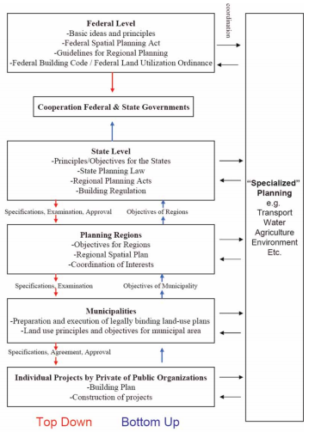
Fig. 11- Spatial Planning in Germany (Newman & Thornley, 1996)
Although, planning is a shared task among all levels of government, the federal government does not create or implement plans, but rather sets the overall framework and policy structure to ensure basic consistency for state, regional and local planning (Newman & Thornley, 1996), while states, regions and municipalities are the actual planning bodies.
The regional development priorities should normally be defined as a tiered system of central places in order to be able to address the regional adjustment processes involved in the provision of public and private infrastructure facilities not only in growing and stagnating regions but also in contracting regions. This type of basic framework of multi-functional central places makes a contribution to ensuring the quality of service provision in the various types of region, although the concrete details vary depending on the starting conditions in each particular case. In order to minimize social disparities across space, a hierarchy of ‘central place’ cities are defined and identified.
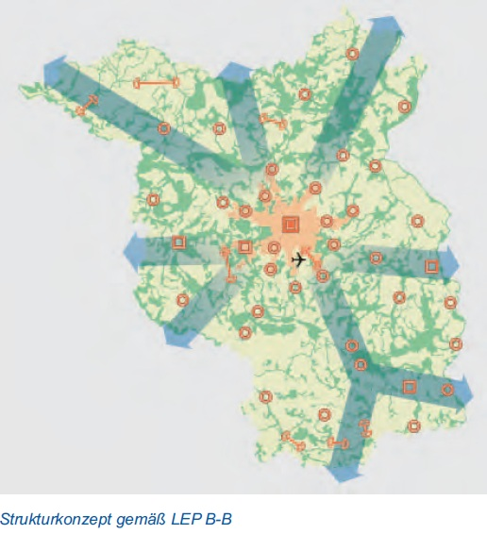
Fig. 12- Berlin Hierarchy of Centers
According to their importance or rank in the urban hierarchy, these ‘central places’ provide services and infrastructure for the surrounding regions. Both federal and state funding is then distributed according to a place’s rank and tasks within the central place hierarchy. Cities with more service functions receive proportionally more funding in order to provide these services (BBR, 2000).
Moreover, in recent years, the concept of central place theory has evolved in the German context towards city networks which are defined as “co-operative forms of communities in a region or in neighbouring regions that are characterised by the fact that the communities act as partners, i.e., they voluntarily and equitably bundle and supplement their capabilities and potential in order to fulfil their tasks jointly, and thus in a more efficient manner” (BBR, 2001).
Interestingly, the ideas of “central place theory” have also made its way in the Albanian planning practice through the General National Plan of Albanian which was approved in 2016. In this case, although a hierarchy of center has been defined, together with their different specificities, it is still to be developed a framework for the implementation of the concept.

Appendix 2 (Case study in Strategic Planning)
In the UK, more specifically in England, local governments are expected to produce Local Development Frameworks. At the center of the local development framework there is the core strategy (territorial strategy) which spans across a wide range of topics such as housing, transport, economy, social development, environment etc. In addition to the core strategy, which offers the basis for the spatial development as well as the land-use plans, LGUs are entitled to draft additional strategic planning documents based on their challenges and needs.
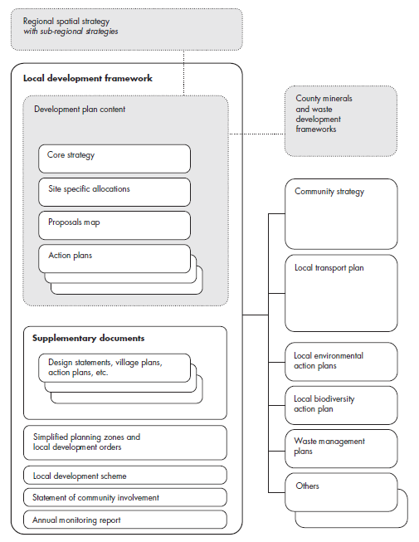
The above scheme, offers the framework for strategic local planning in the UK. As it can be seen, as part of the different supplementary documents, the local councils/counties can also draft different sectoral strategies which are specific on different issues. In most cases these are related to transport, waste, or environmental issues. However, there are also cases which include tourism development, urban-rural strategies, economic development etc. These strategic plans, not always do take a spatial approach.
In a similar manner, Germany, also offers flexibility in terms of strategic planning. Considering the similarity with the functional area approach, strategic planning as it can be seen from the below diagram, operates at a larger scale. Even in this case, there are different issues which can be addressed through strategic planning. Anyway, in both cases, spatial planning is settled in different historic and social context, thus more details and analysis are necessary in order to see ways of transferring a similar approach. Here it is done merely for illustration processes, to show that even in more developed states there are also informal strategic planning processes which not necessary are binding by law.

