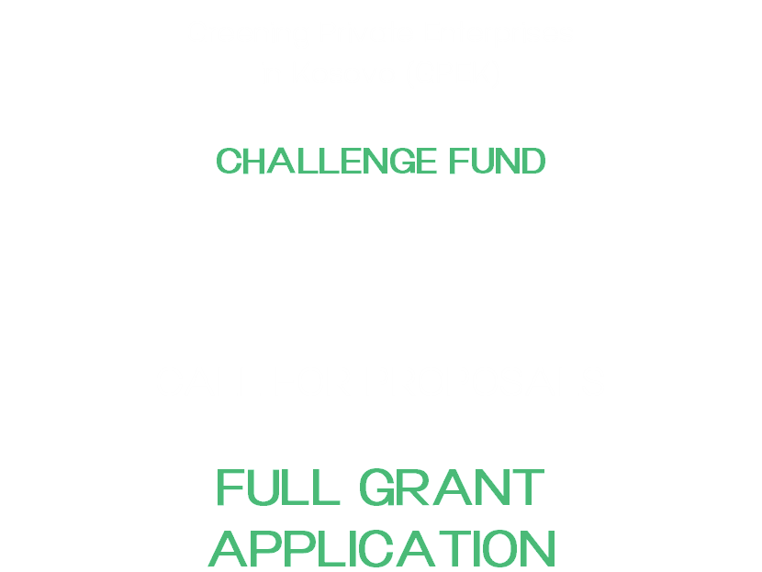





Greening Private Enterprises in Kosovo (GPEK) is a project of the Swiss Agency for Development and Cooperation (SDC), co-funded by Sweden and implemented by Helvetas.
Greening Private Enterprises in Kosovo (GPEK)

CHALLENGE FUND
FULL GRANT APPLICATION

Section 1: Applicant Information
Full legal name of Applicant | (As per registration certificate, in local language)
Partner applicant (if applicable, and their role)
Company description / activity
Legal Form | e.g. LLC, Individual Business
Registration Number
Year Founded
Main Sector / Activity
Number of Employees | Full time: | Part time:
Email
Telephone Number
Turnover | 2025: € | 2024: €
Net Profit / Loss | 2025: € | 2024: €
Ownership Structure (incl. shareholders %)
Beneficial Owners (>25%)
Affiliated / Related Companies (if any)
Bank Name

Project Title
Project Objective
Project Location
Project Duration (Start–End)
Project cost | Grant fund requested by GPEK | €
 | Cost-share (min. 30% of total costs) | €
 | TOTAL | €
I/we certify that all information provided herein and in any attachments is accurate and complete to the best of my/our knowledge.

Head of Company |  | Signature |  | Date
Section 2. Full Grant Application information
2.1 Background and Rationale of the Proposal (not more than ½ page)
Describe the proposed activity and the main problems/issues that it will address.

Problem / Opportunity
Project Objective(s)
Proposed Solution

2.2 Relevance of Proposed Activity to Objectives of GPEK Project (not more than 2 pages)
Explain how your proposed activity is in line with the objectives of GPEK, as set forth in the Call for Proposals. Clearly identify and describe the environmental dimension of the project, specifying which green criteria it addresses — whether through the introduction of new or improved green technology, improvements in resource efficiency or cleaner production processes, the application of circular economy principles, or compliance with relevant environmental standards.

What is innovative in the Kosovo context?
Type of innovation | ☐ New technology ☐ Adaptation ☐ Process improvement  ☐ Business model
Target customers / market
Environmental impact indicators | Energy use / CO₂ emissions / Water use / Other (specify baseline & target)

2.3 Technical Feasibility & Implementation (not more than 2 pages)
Present a clear and realistic implementation plan that outlines defined activities, timeline, and measurable milestones that demonstrate how the project will be delivered within the proposed timeframe. Risk mitigation measures should be explicitly addressed, identifying key risks and the practical steps in place for managing them. Explain how the project attracts and complements private investment rather than displacing it.

Activity | Expected Output | Timeline | Responsible | Related Budget

Milestones (linked to disbursement):
Milestone | Deliverable | Timeline | Verification Method

Technology / Solution Description
Level of maturity | ☐ Idea ☐ Pilot ☐ Scaling
Has this solution been used before? Where?
Key inputs (equipment, skills, suppliers)
Suppliers identified? | ☐ Yes ☐ No
Additionality: Without Challenge Fund support? | ☐ Not implemented ☐ Delayed ☐ Reduced scale
Key barriers addressed | ☐ Financial ☐ Technical ☐ Market

2.4 Business Case & Financial Viability (not more than 1 page)
Present a clear and credible business case demonstrating how the project will achieve financial sustainability. Justify why the support requested is the minimum necessary to make the project viable, explaining what funding gap it addresses and how other funders or partners are contributing.

Revenue streams
Cost structure
Expected profitability
Expected payback period
Break-even expected? | ☐ Yes ☐ No
Ability to pre-finance costs before reimbursement? | ☐ Yes ☐ No
Existing demand (contracts, LOIs, etc.)

Co-Financing Sources:
Source | Amount (EUR) | Status (secured / pending) | Evidence attached (Y/N)

2.5 Expected Results (not more than 2 page)
Describe the expected results of the proposed activities and how they relate to the proposed activity goal and objectives. List anticipated and achievable results as measurable outcomes. Each result should be directly linked to a specific objective. Proposed activities should be linked to call goals and intended results, as stipulated under section 11 of the CfP-2026-01.

Indicator | Baseline | Target | Measurement Method
Energy use (kWh)
CO₂ emissions
Water use
Other (specify)

Social Impact Indicator | Current | Expected
Jobs created (#)
Jobs improved (#)
Women employed (#)
Other social benefits

2.6 Beneficiaries, Target Groups and Main Stakeholders
Describe the specific beneficiaries and target groups of your grant activity and all relevant stakeholders. Explain which groups/individuals are your supporters, potential allies, and/or competitors or other, and briefly define how your company will interact with these groups throughout implementation of the grant activity.

2.7 Partners
List the main collaborating partners in implementing the grant activity. Such partners are critical to the successful implementation of the grant activity. They may include, but not limited to, private sector companies, government agencies, donor organizations, non-governmental partners, or others. Please briefly describe their specific role in the grant activity, if applicable.

2.8 Systemic Impact (Scalability & Sustainability) (not more than 2 page)
Explain how the action will continue independently after the grant period, underpinned by a credible plan and sufficient organisational capacity. How does this project contribute to broader systemic or market change such as shifting sector norms, improving practices, or strengthening value chains? Outline any realistic potential to attract future private finance, including banks or investors, as evidence that the project can scale and sustain itself.

Potential for scaling
Potential for replication by others
Broader market / system relevance
Key competitors / alternatives

Section 3: Institutional Capacity (not more than 3 pages)
3.1 Description of the applicant/company
Describe your company’s mission statement/purpose and the primary technical sectors of your company’s operation. Indicate the number of staff employed by your company.

3.2 Applicant’s/Company’s experience
Describe your company’s experience, skills and knowledge in the technical area of the proposed grant activity. Clearly indicate your company’s recent experience relevant to the proposed activities, mentioning specific successes achieved. Indicate partnerships and cooperation with other stakeholders that may have led to your success.

3.3 Relevant Experience
Briefly describe your experience implementing similar or related activities to the proposed project.

Experience with similar projects
Largest project implemented (EUR)
Experience with donor-funded projects

3.4 References
List the names and contact information of at least three other donors/funding sources that have previously or currently support your organization through direct grants or contracts. Please indicate the project duration and year it was implemented. Provision of relevant evidence or references of such implementation adds to the credibility of the information provided.

Name of Funding Source | Contact Person, Name, Title, Email Address, Telephone Number | Name of Grant/Project | Brief Project Description | Project Period of Performance

3.5 Budget Proposal and Budget Narrative
Complete a detailed budget proposal in accordance with the Excel format provided as part of the Full Grant Application form. Please provide in the relevant column (column B) of the budget table, a description of the budget that explains in detail the proposed costs of the grant activity.
Section 4: Supporting Documents
Please submit electronic copies of the following documents together with this form:

- Ownership documentation (incl. shareholders %)
- Financial statements (last 2 years)
- Bank confirmation letter
- Co-financing evidence (if applicable).

