




Greening Private Enterprises in Kosovo (GPEK) is a project of the Swiss Agency for Development and Cooperation (SDC), co-funded by Sweden and implemented by Helvetas.

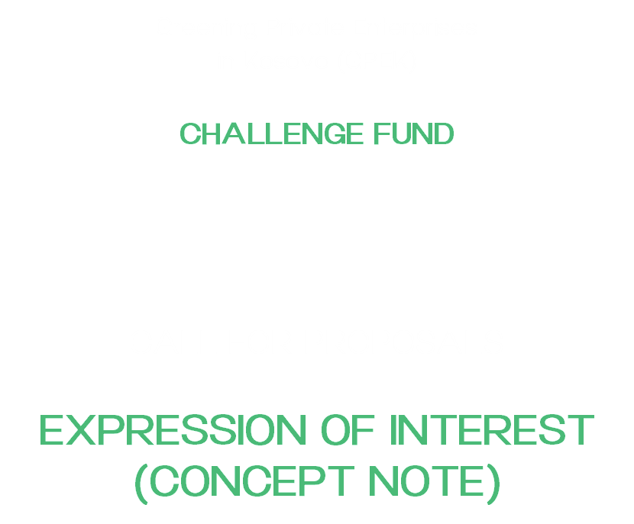

Greening Private Enterprises in Kosovo (GPEK)
CHALLENGE FUND

CALL FOR PROPOSALS
EXPRESSION OF INTEREST (CONCEPT NOTE)

Section 1: Applicant information

Full legal name of Applicant
(As per registration certificate, in local language)
Partner applicant (if applicable, and their role)
Company description/activity:
Email:
Telephone number:
Webpage:
Applicant legal status: | e.g. LLC, Individual Business
Year founded:
Turnover | 2025: € | 2024: €
Registration number:

1.1: Project details
Project Title:
Project Objective:
Project Location:
Project Duration:
Project cost: | Grant fund requested by GPEK | €
Project cost: | Cost-share (min. 30% of total costs) | €
Project cost: | TOTAL | €
I/we certify that all information provided herein and in any attachments is accurate and complete to the best of my/our knowledge.

Head of Company |  | Signature |  | Date

Section 2: Expression of Interest

Submitting an Expression of Interest (EOI) is the first step in the grant selection process. Your EOI should clearly and concisely describe your proposed activity, covering its relevance, purpose, objectives, key activities, and expected results all supporting the GPEK Project's objectives, as outlined in the Call for Proposals.
Once EOIs have been reviewed, applicants whose submissions are successful will be invited to the second phase of the competition. At that stage, applicants will be invited to a full grant application based on the concepts and technical approach presented in their EOI. Please follow the page restrictions and formatting guidelines carefully, as outlined below.

- Background and Rationale of the proposal (not more than ½ page)
Describe the proposed activity and the main problems/issues that it will address.

- Relevance of Proposed Activity to Objectives of GPEK project (not more than 1 page)
Explain how your proposed activity is in line with the objectives of GPEK, as set forth in the Call for Proposals. Clearly identify and describe the environmental dimension of the project, specifying which green criteria it addresses whether through the introduction of new or improved green technology, improvements in resource efficiency or cleaner production processes, the application of circular economy principles, or compliance with relevant environmental standards.

- Technical feasibility & implementation (not more than 1 page)
Present a clear and realistic implementation plan that outlines defined activities, timeline, and measurable milestones that demonstrate how the project will be delivered within the proposed timeframe. Risk mitigation measures should be explicitly addressed, identifying key risks and the practical steps in place of managing them. Explain how the project attracts and complements private investment rather than displacing it.

- Business Case & Financial viability (not more than 1 page)
Present a clear and credible business case demonstrating how the project will achieve financial sustainability. Justify why the support requested is the minimum necessary to make the project viable, explaining what funding gap it addresses and how other funders or partners are contributing.

- Expected Results (not more than 1 page)
Describe the expected results of the proposed activities and how they relate to the proposed activity goal and objectives. List anticipated and achievable results as measurable outcomes of the proposed activities. Each result should be directly linked to a specific objective. Proposed activities should be linked to call goals and intended results, as stipulated under section 11 of the CfP-2026-01.

- Systemic impact (scalability & sustainability) (not more than 1 page)
Explain how the action will continue independently after the grant period, underpinned by a credible plan and sufficient organizational capacity. How does this project contribute to a broader systemic or market change such as shifting sector norms, improving practices, or strengthening value chains. Outline any realistic potential to attract future private finance, including banks or investors, as evidence that the project can scale and sustain itself.

- Relevant experience (not more than ½ page)
Briefly describe your experience implementing similar or related activities to the proposed project.

- Proposed budget and cost-share
List anticipated costs and expenses using (and adapting) the table below, which is illustrative.

Budget categories | Requested by GPEK | Applicant cost-share (cash) | In-kind support
Personnel and Consultants | EUR | EUR | E.g office
Programmatic Costs
Administrative/Office Costs
Sub total
Total

Section 3. Supporting Documents
Please submit soft copies of the following documents together with this form:
- Business Registration Certificate
- Fiscal / Tax Registration Certificate
- Ownership Structure and CVs of Key Personnel (max. 3)

Section 4. Declaration of Politically Exposed Persons (PEP)

A Politically Exposed Person (PEP) means any domestic or foreign natural person who is or has been entrusted with a prominent public function, including:
- President, Prime Minister, minister, deputy minister, political advisor, chief of staff
- Members of parliament
- Members of leading/governing bodies of political parties (central or local level)
- Members of the Constitutional Court and Supreme Court
- Ambassadors, chargés d'affaires, or high-ranking military officials
- Mayors, deputy mayors, municipal directors, political advisors and chiefs of staff to mayors and deputy mayors
- Members of political party lists running for local or national elections
- Members of Municipal Assemblies
Persons holding any of the above positions are considered PEPs if they currently hold that office or have done so within the two (2) years prior to the date of this application.
To be eligible for Helvetas funds, such persons must not hold a leading position in the applying SME, including:
- CEO;
- Head or member of the Board;
- Manager (programme or finance) or any similar senior-level position.
By submitting this form, I, the authorised representative of the applicant, declare that: none of the persons in leading positions within our company fall under the category of Politically Exposed Persons as defined above.

Full Name & Signature: __________________________________
Date and Place: __________________________________

