  - Brokering knowledge for policy
  - a case study on dldp’s role in drafting a new law on local government finance in Albania
  - Tirana & Bern
  - December 2016
Valbona Karakaçi and Sarah Byrne, with contributions from Ornela Shapo, Stefan Pfaeffli, Erton Kashta and Jens Engeli

Introduction
Local governments in Albania are currently in the midst of a multi-year and comprehensive reform process that is transforming the form and function of local governments. The reform process emerged from an assessment that the relatively high number and small size of local government units and poor quality public services were constraining and fragmenting development potential. Driven by a strong political will that informed and influenced the national government’s current mandate, this reform process has tackled the territorial scope of local governments, the functions they are responsible for carrying out, the professionalism of the local civil service and local government financing.
The reform process represents both opportunity and risk for local governments. Ensuring that the reforms address local governments’ interests and practical concerns is an important contribution to achieving the reform process’ dual aims of improved governance (including service delivery) and local development. However, while the local level is directly and significantly impacted by the reform process being carried forward by the national level, local governments and their associations do not have the necessary capacities, resources and platforms to form or express a unified position, on either a technical or a political level. They are further challenged by the responsibility to maintain public service delivery performance at least at pre-reform levels while the reforms are on-going and causing significant turbulence.
With its many years of experience supporting local governments in Albania, high level of trust and pool of expertise on the topic of public finances, the Decentralisation and Local Development Program (dldp) was well placed to expand its partnerships at the national level and contribute significantly to several of the elements of the local government and decentralisation reform package envisaged by the Government of Albania. Indeed, this is the clear aim of the goal defined at the beginning of the project’s third phase, as the scope of the Government of Albania’s reform objectives became clear: better provision of socially inclusive services through an advanced decentralisation reform and strengthened local democracy. Dldp thus undertook to contribute to the reform process, aiming to achieve a more conducive framework for local governments and in particular one enabling better public service delivery (defined as one of dldp’s three outcomes).
Dldp’s contribution in national policy-making processes, as will be described in this case study, centred around facilitating dialogue spaces and feeding them with analysis and learning based on international good practice and the practical experience of Albanian local governments. This case study describes and analyses one particular strand of dldp’s policy dialogue activities: the process of developing the new law on local government finances. However, this particular case can also be considered as a representative example of dldp’s policy influence strategy in general, in particular the iterative and mutually reinforcing cycling between know-how and dialogue processes, the central knowledge brokering role and emphasis on collaboration and consensus building.

Knowledge brokering, policy-making and policy influence
Knowledge brokering is a complex process that goes beyond the transfer of information from researchers to decision makers or encouraging policy makers to base their decisions on evidence coming from research. This one-way transfer model is unsatisfactory for a number of reasons, including that policy makers also need to take into account other factors such as political feasibility and priorities or personal career concerns. Furthermore, in a context of decentralisation, decision-makers at national level should have access not only to knowledge from research but also (tacit) knowledge from local government practitioners. According to research undertaken in the public health sector (Ward et al, 2009), three different approaches to knowledge brokering can be identified:
- The first approach relates to the creation, diffusion and use of knowledge, or classical knowledge management activities. In this approach, brokering is seen as a way of facilitating or managing these activities and the knowledge brokers act as 'knowledge managers'.
- In the second approach, brokering focuses on the interface between the ‘creators’ and ‘users’ of knowledge and seeks to foster links between the two. In this approach knowledge brokers act as ‘linkage agents, relationship builders, and consensus facilitators.’
- In the third approach brokering is designed to enhance access to knowledge by providing training or coaching to knowledge users. In this context knowledge brokers act as ‘capacity builders’.
These three different knowledge-brokering approaches can be used at all stages in the policy cycle, a simplified version of which is represented below:
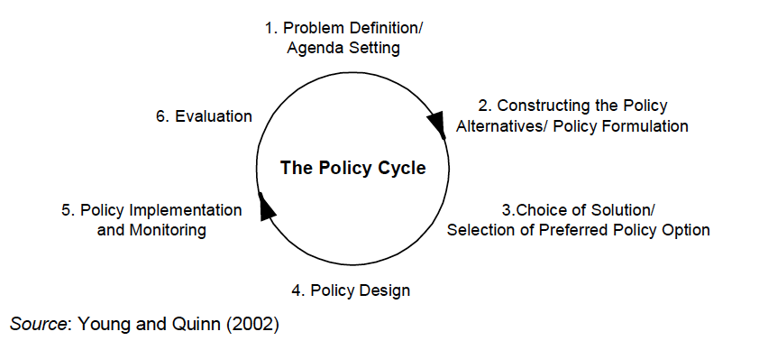
Figure 1: The policy cycle (Young and Quinn, 2002)

Dldp’s approach to knowledge brokering combines all three approaches: managing knowledge, linking actors and building capacities. The project used its combined strengths in all three areas to strategically guide and respond to the demands of the policy cycle of Albania’s new draft Law on Local Government Finance. Due to its high degree of flexibility and responsiveness, the project was able to contribute to documenting knowledge, facilitating relationships and building capacities on both a “just in case” and a “just in time” basis. In order to trace out the different impacts of dldp’s interventions in the law-making process, we undertake a differentiated analysis that seeks to disentangle the different elements behind the outcome of a particular draft law or endorsed policy. These different elements are illustrated in the diagram below:
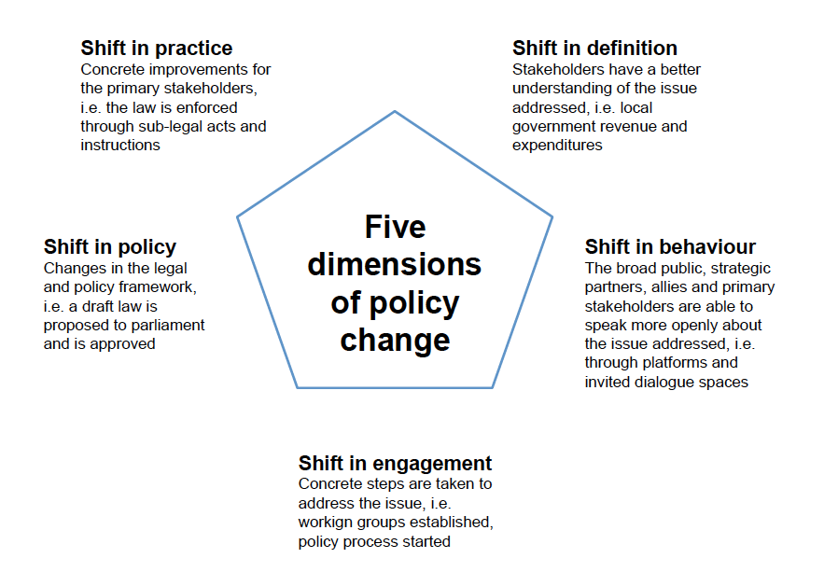
Figure 2: The five dimensions of policy change (HELVETAS Swiss Intercooperation, 2015)

Process description and policy impact

A comprehensive reform package
The new Law on Local Government Finances is a key part of the package of decentralisation reforms initiated by the Government of Albania, designed to align local and intergovernmental finance systems with the increased decentralisation of functions. Key issues include the match between funds and functions, the predictability of the intergovernmental transfer system, the fund generation options available to local governments and the transparency and accountability of budget processes.
The key elements of the reform package are noted below.

Figure 3: Milestones of the Albanian decentralisation and local governance reform process 2013-present

Public finance reform and decentralisation reform are highly intertwined. Proper public finance management (PFM) processes are needed at the local level as a prerequisite for a successful decentralization. These processes depend on having a clear assignment of functions the local government is responsible for and a relatively stable and predictable finances. However, these two conditions have not been met to a sufficient level in Albania, according to public finance experts. Local governments still depend to a large extent on national grants; only part of these grants can be reliably estimated when the medium term budget program is prepared. In addition, local governments have only limited rights to collect their own revenues. These deficiencies undermine policy based budgeting and the credibility of the budget in the short and medium term; they could have negative effects on the effectiveness and efficiency of budget implementation and on the sustainability of public finances at the local level. Thus there was a need for a significant reform of local government finances, as a key both to the success of decentralisation and the improvement of local governance.

A long term and respected partner on local government finance
Dldp, and through it Swiss Cooperation, have been a long term and respected partner in Albania on the topic of local government finances. For dldp, public finance management (PFM) is at the heart of local governance and decentralisation as it key to the functioning of the “engine room” of local governments. Building on its extensive practical experience working directly with local governments in Northern Albania on PFM, dldp also has established excellent contacts with the national level especially (but not only) in the area of local PFM. According to an external expert, dldp is highly respected for the quality of its conceptual contributions for improving PFM processes at the local level and for its support activities. The Ministry of Finance’s (MoF) Directorate for Intergovernmental Fiscal Relations regularly consults dldp before the budgeting guidelines are issued, and the input of dldp is taken into consideration in many cases. Furthermore, the MoF fully stands behind different tools developed by dldp, for example the financial planning tool, and promotes their application at the local level countrywide. Furthermore, the Directorate for Intergovernmental Fiscal Relations crosschecked and supported the finalization of dldp’s training handbook on strategic development planning and performance-based budgeting in the medium-term. Through these various knowledge brokering activities, dldp established itself as a trusted partner – and on this basis was able to contribute effectively to developing the new Law on Local Government Finance.

Three cycles of brokering knowledge and consensus
Dldp’s approach to generating, informing and influencing policy dialogue around the new Law on Local Government Finances was an iterative one, tacking between developing know-how (capitalising practical experience in Albania, assessing and analysing international good practice), facilitating and contributing to dialogue spaces and processes and capacity development support. This approach aimed to generate agreement on key principles, identify and reduce resistance and broker consensus. The approach is illustrated in the diagram below.

Figure 4: An iterative approach between know-how development and dialogue in cycles
In the diagram above the boxes in red represent knowledge outputs produced or supported by dldp, the boxes in green represent moments of consensus building and the boxes in purple represent specific outputs relevant to the policy cycle. On-the-job coaching and capacity development of partners, including staff of the Ministry of Finance, was ongoing throughout these cycles.
The process of developing the new Law on Local Government Finance can be grouped into three cycles – the first develops a model based on theory and international good practice, with initial adaptations to the Albanian context. Here dldp developed a model on the public finance management elements that it thought important to include in the new Law, with the support of international and local experts. This model was adapted to the Albanian context and shared in various dialogue platforms, some of which were facilitated by dldp. At the end of the first cycle there were two different models for the new Law, essentially based on two different sets of experiences from other countries. The first model suggested that a local finance law should cover only revenues and the second model, the one supported by dldp, suggested that the law should regulate both expenditure and revenue, so that income generation is matched with appropriate fiscal discipline.
The second cycle focussed intensively on contextualisation and generating an agreement on what would be the best model for Albania. Dldp proactively sought dialogue with those actors most resistant to the model the project was proposing, including proponents of the alternative model amongst development partners and projects. Dldp and its associated experts sought to understand the different model and the particular points of resistance. Dldp and its experts analysed local finance laws from different countries that followed one of the two models. The project also analysed the dense legal framework of Albania, including the twelve other laws that have a bearing on local finance. At the same time dldp engaged in a quick PFM assessments of selected local governments in order to get insides of PFM issues in Albania context at the local level. The report concluded with findings and recommendations that were reflected on the first draft of the Local Finance Law. The findings and recommendations of the quick PFM assessment were validated with local and central government representatives. The PFM assessment (a mini PEFA) was shared with donor community and international stakeholders active in public finance issues, including the IMF and World Bank.
On the basis of this know-how, dldp participated in debate and discussion about the pros and cons of the different models and what would be the best fit for Albania. At the end of this process, an agreement was reached to go ahead with a model including both local government revenues and expenditures, as dldp had recommended. Thus public finance theory as well as practical experience from other countries were analysed and contextualised to result in an agreed general model for Albania.
The third cycle takes the process from the general model to the specific “nitty gritty” details, while also broadening the scope of actors involved. The third cycle thus sought to deepen the agreement to the level of details and to engage in a multi-stakeholder process of recognising and reaching consensus on the proposed model. While one key driver within the respective institutions essentially led the first cycles, in particular the Ministry of Finance, the third cycle disaggregated the model into its pillars and sought agreement at a departmental level. The project engaged in a series of parallel and bilateral consultations with different department heads within the Ministry of Finance to respond to critiques and ensure agreements on the specific details of the proposal. Once agreement was reached with each of these sections, the Ministry of Finance invited all stakeholders together for a common dialogue and to approve the final model on the basis of the already reached agreements. Dldp further shared the proposed model with important international actors in the field of public finance, including institutions such as the IMF, World Bank and EU. In this third cycle the proposed model was thus recognised and recommended by external actors, and adapted according to the concerns of the different departments within the Ministry of Finance. The result was a model based on international good practice, adapted to the Albanian context and around which there was a broad and multi-stakeholder consensus aiming to support not only passing the Law but also implementing it.
Now that a technically rigorous and consensus-based model is on the table, dldp steps back, leaving space for the Ministry of Finance to take over the process, in particular the national consultation with concerned actors such as mayors. From the technical process, the model now enters into the political and legislative process of debating and approving the Law in Parliament. Once the Law is approved, dldp is committed to providing support for its implementation – for example in the form of drafting sublegal acts – and in continuing to support local governments to improve their public finance management capacities and performance.

Analysis
Enabling factors – dldp’s influence in the process of drafting a new Law on Local Government Finances was enabled by the political context, alignment with the interests of important actors, earlier analyses already conducted and strong support from its donor (SDC). The political context, as outlined above, is one of comprehensive and wide-reaching reform to decentralisation and local governance at the level of both structures and systems. It was thus a highly propitious time for a project such as dldp to realise an agenda of policy influence, on the basis of several years of practical work experience in the field of public finance management at the local level. This experience contributed both to dldp’s acceptance by national actors and the relevant evidence the project had at hand from local governments. Dldp also could build on other technical support provided in the frame of this comprehensive reform process, including an analysis of the new functions transferred to local governments.
Dldp’s influence was also enabled by its ability to mobilise the support of highly respected international (Swiss) expertise, and interact with other international cooperation projects working in the field of PFM, principally the USAID funded project PGLP. A further significant fact is that the interests of both the Ministry of Finance and Heads of Finance Departments in dldp partner municipalities were aligned around having a comprehensive and rigorous Local Finance Law covering not only revenues but also ensuring fiscal discipline in expenditures. Finally, SDC’s in this process has been very important, serving as a balancing mechanism between enabling and constraining factors. SDC has also played a key role in creating a linkage between the political (ministerial) level and the technical efforts, in order to bring political factors to an understanding of the importance of the technical process carried out and the reasoning behind that process.
Constraining factors– dldp’s influence was constrained, rather ironically, by actors whose general aim was aligned with dldp’s to develop a high quality law to guide the financial framework of local government. However, these actors, including other development partners, had a different vision of what the new law should address: whether it should cover revenues only, or whether it should regulate both revenues and expenditures. Thus, not for the first time in the field of international cooperation, there were two competing models promoted by different development partners and before addressing the content of the law itself, the question of the model had to be resolved. In the end, the Ministry of Finance was convinced by dldp’s model and the two-part framework (revenues plus expenditures) was introduced in the new draft law.
Policy impact– dldp’s policy impact is summarised in the diagram below according to the five dimensions:
Figure 6: dldp's impact according to the five dimensions of policy change

Knowledge brokering: Through its various lines of intervention, dldp is a strong and experienced player of all three knowledge brokering roles. Specifically with regards to local finances, examples include
- Knowledge management: dldp has mandated local and international public finance experts to produce several important studies (see references), organised high profile events at national level, hosted a popular knowledge sharing platform and convened regular meetings of municipal experts (known as centres of competence).
- Linking actors, building relationship and brokering consensus: throughout the policy making process (see figure 4) dldp proactively and creatively made spaces where different stakeholders can exchange and regularly participated in spaces created by other actors to order to share its experience and present its position. These initiatives aimed at understanding the views of other actors and to influence shifts in the policy process responsive to both the practical situation of local governments as well as international good practice in this area.
- Capacity development: capacity development support, in the form of on-the-job coaching, study visits abroad, trainings, etc. was ongoing throughout this process.
Outcome: the draft Law on Local Finances is the product of an excellent collaboration between dldp, PLGP/USAID and Ministry of Finance (MoF). Such a collaboration comes as a result of a serious and long term engagement in PFM issues, with a special focus on local expenditures (dldp) and local revenues (PLGP). Following an initial interaction among MoF and the two programs it was agreed that the draft law would follow the model of including both revenues and expenditure sides of local finances. Local and international expertise was engaged by both programs to develop each part of the law, making efforts to come to common understanding on inter-related issues. Various expert round tables made it easier to share and discuss methodological issues, intermediate activities and timetables, findings and inputs. Furthermore, dldp invited MoF and PLGP to participate in its activities at the local level in order to assure an efficient and transparent advancement of the process and the products. The final draft law document was elaborated along with MoF experts in a number of small group workshops, addressing all sub-thematic issues.

Lessons learned
There are two key learnings that can be drawn from dldp’s experience of contributing to Albania’s new Law on Local Government Finances. These relate to the position of the project (and of development cooperation more generally) as knowledge broker in the policy-making process and to the disconnect between technical and political processes.
The first learning is that while dldp very successfully played the role of knowledge broker in the process of developing the new law, as outlined above, the project’s brokerage function highlights important gaps in the policy-making process. The transmission of know-how from local governments to the national government is either undertaken directly - or facilitated - by development actors. Likewise, scientific and expert knowledge is mandated and channelled into the policy process by development actors. Thus development actors serve as key knowledge brokers connecting national government actors (in the case the Ministry of Finance) with the knowledge needed for informed policy-making from both a) local governments and b) external experts. While in the short term this may be effective, in the longer term its sustainability is questionable. It also risks leading to policies that are politically not feasible to implement or coherent with the range of other interconnected policies.
In the process outlined above, it is evident that there are two key gaps in the local government policy-making processes. The first is a mechanism for generating collective voice among municipalities and bringing this voice into policy processes. Through its years of experience working with local governments and through using mechanisms such as Centres of Competence (inter-municipal working groups) as a sounding board, dldp was in a position to put the concerns of municipalities on the table. In the absence of other non-partisan mechanisms for generating collective voice among municipalities, projects like dldp play an important brokering role connecting the local and national level. Interactions with partner municipalities suggest that this is very much appreciated and necessary. However successful dldp (and other development projects) are at this, however, a project like dldp is always only a temporary measure and a more sustainable and legitimately representative mechanism, such as a functional local government association, should perhaps not be side-lined.
The second major gap is in terms of the capacities within the system to provide evidence and research for policy-making. Here as well dldp in particular, but development partners more generally, bridge the gap by bringing in international experts and strengthening national expert pools. But these experts tend to remain independent and associated to the process through development partners, rather than through national public or private research institutions, think tanks, etc., for example.
These two cases call for a serious reflection on whether development actors are only temporarily stopping gaps in policy-making systems or whether they are, through their gap stopping mechanisms, actually preventing the emergence of nationally owned mechanisms. The great need for innovative projects like PERFORM that seek to address these systemic issues is thus evidenced by the particular case of the process of making a new law on local government financing.
The second learning that arises from dldp’s experience in supporting the development of the new Local Governance Finance Law is the persistence of a disconnect between technical and political processes. Though it has long been axiomatic that the technical is political, dldp found that development partners in particular reproduced a separation between technical and political activities. A development project like dldp was encouraged to remain within the technical domain, working with partners like the technical experts in the Ministry of Finance and international organisations to prepare a draft law. However, dldp was not encouraged to interact with political actors such as the members of the parliamentary Finance Commission, who also have an important role to play in the law-drafting process. Thus the vast knowledge developed through the process of making the draft law together with the Ministry of Finance was kept within the technical-administrative domain and not shared with parliamentarians responsible for analysing and debating the draft law. Dldp was thus not in a position to broker knowledge sharing between a technical law drafting process and a political decision-making process. While dldp’s donor, SDC, did ensure a technical-political linkage to a certain extent, it may be worth reflecting on how these linkages can be strengthened within the Albanian system and most effectively supported by external actors.
Poorly or insufficiently informed legislative actors are not in a position to perform their democratic role in the policy-process or to assure their check and balance function regarding the executive. Perpetuating this disconnect risks leading to policies devoid of content, passed simply for the approval of external actors (whether international financial institutions or EU accession criteria) – or technically excellent proposals that lack political willingness for approval or, importantly, implementation. Here the recommendation would be for development partners to consider working more closely with legislative actors – from local councils to national parliaments, empowering them to effectively play their democratic role in policy-processes. A number of other SDC projects in the region are already working along these lines at both national and local levels (i.e. support to parliamentary commissions in Serbia, empowering local councils in Macedonia).
The foregoing critical comments about dldp’s knowledge brokering role are not intended to detract in any way from the very significant achievements of dldp and partners in contributing to a draft law that meets high technical standards and a high level of consensus among technical experts - in the Ministry of Finance and local government finance departments, as well as international organisations. Given the rapid pace and high complexity of the on-going local government reform process, as well as the high challenges faced in the field of local government public finance (insufficient funds to cover services, high levels of debt, lack of technical capacities), this achievement should not be under-estimated. The law as drafted sets an excellent framework for the future of local government in Albania, and is an achievement Swiss cooperation can be proud to have supported.
Dldp is committed and prepared to follow this up with support to implementing the law, for example in the formulation of sub-legal acts. Furthermore, capacity development activities remain ongoing, supporting both local and national governments to develop the skills needed to effectively implement the new law.

References
Braho, Antonin (2013). Thematic Evaluation: dldp’s Support on PFM. Tirana: dldp.
HELVETAS Swiss Intercooperation (2015). Advocacy Concept. Zurich and Bern: HELVETAS Swiss Intercooperation.
Pfaeffli, Stefan (2013). SDPeMTBP approach of dldp as a contribution to the PFM reform at the local level in Albania: Review and Outlook. Luzern: HSLU and dldp.
Shapo, Ornela; Vjero Vasilika; Fara Elida; Oshafi Lindita (2016). Quick PFM assessment on three selected municipalities (Lezha, Shkodra and Durres) / A mini PEFA assessment to support law on local finance design process. Tirana: dldp.
Shapo, Ornela; Pfaeffli Stefan; Titka Mirza; IP3 (2016). Monitoring the new functions transferred from the Central Government to Municipalities. How prepared are municipalities to take over these functions? Tirana: dldp.
Sutcliffe, Sophie and Julius Court (2005). Evidence-Based Policymaking: What is it? How does it work? What relevance for developing countries? Working Paper. London: Overseas Development Institute.
Ward, Vicky L., Alan O. House and Susan Hamer (2009). Knowledge brokering: Exploring the process of transferring knowledge into action. BMC Health Services Research 9:12.
Young, Eoin and Lisa Quinn (2002) Writing Effective Public Policy Papers: A Guide to Policy Advisers in Central and Eastern Europe. Budapest: Local Government Institute.

See also the documentation of dldp’s contribution to the territorial and administrative reform process, specifically how the functional area approach introduced by dldp influenced the eventual delimitation of new local government units: https://assets.helvetas.org/downloads/report__capitalization_dldp_functional_area_study.pdf.
http://www.km.dldp.al/public-finance-management/?lang=en
http://www.perform.network/en/

